PROJECT REPORT

ON

**“ONLINE JEWELLERY SHOPPING”**

Submitted in the Partial fulfillment of the requirement for the Award of Degree of

**Bachelors of Technology**

In

**COMPUTER SCIENCE & ENGINEERING**

Batch (2017-2021)

**SUBMITTED BY:**

Name: Harjot Kaur

University Roll No: 1705788

**SUBMITTED TO:**

Department of CSE

**CERTIFICATE**

**ACKNOWLEDGEMENT**

In the accomplishment of this project successfully, many people have bestowed upon me their

blessings and the heart pledged support, this time I am utilizing to thank all the people who have been concerned with this project.

Primarily, I would like to thank God for being able to complete this project with success. Then, I would like to thank “Global Group of Institutes” for providing with an opportunity to pursue our minor project as it is important part of B. Tech and it is the one that expose us to the industry standards and make us adapt our self to the latest technologies. At the same time, it gives an experience of working on real time scenarios of the organizations. I would like to add my deepest gratitude for our entire faculty of “CSE Department” at “Global Group of Institutes” from where I have learnt the basics which have helped us a lot in completion of this project.

**Harjot Kaur**

**B.Tech(CSE)**

**1705788**

**TABLE OF CONTENT**

**CHAPTER-1**

**Introduction to Project**

1.1) About Online Jewellary Shopping -------------------------------------------------- 7

1.2) Funcationaltity of Online Jewellary Shopping------------------------------------- 7

1.3) Salient Features of Online Jewellary Shopping--------------------------------- 8-9

**CHAPTER-2**

**Technologies Used**

2.1) About Android------------------------------------------------------------------- 10-17

2.2) About Java ------------------------------------------------------------------------ 18-23

2.3) About JSP ------------------------------------------------------------------------ 24-25

2.4) About Sql ------------------------------------------------------------------------------ 26

**CHAPTER-3**

3.1) Snapshots-------------------------------------------------------------------------- 27-51

**CHAPTER-4**

**Results and Discussions**

4.1) Need for Online Jewellery Shopping ---------------------------------------------- 52

**CHAPTER-5**

**Conclusions and Future Scope**

5.1) Future of Online Jewellery Shopping--------------------------------------------- 53 BIBLIOGRAPHY ------------------------------------------------------------ 54

**LIST OF FIGURES**

Fig-1) Index Page -------------------------------------------------------------------------- 27

Fig-2) Customer Register Page --------------------------------------------------------- 27

Fig-3) Customer Login Page-------------------------------------------------------------- 28

Fig-4) Home Page-------------------------------------------------------------------------- 28

Fig-5) View all Categories---------------------------------------------------------------- 29

Fig-6) Banners------------------------------------------------------------------------------ 29

Fig-7) New Offers ------------------------------------------------------------------------- 30

Fig-8) View all Products ------------------------------------------------------------------ 30

Fig-9) Product Detail Page --------------------------------------------------------------- 31

Fig-10) Add to Cart ----------------------------------------------------------------------- 31

Fig-11) Checkout Page ------------------------------------------------------------------- 32

Fig-12) Payment Option Page ----------------------------------------------------------- 32

Fig-13) Order Placed Successfully Page ----------------------------------------------- 33

Fig-14) Online Payment Option --------------------------------------------------------- 33

Fig-15) Select cards, UPI and more Payment Option page -------------------------- 34

Fig-16) My Orders Page ------------------------------------------------------------------ 34

Fig-17) Validiations for Wrong credentials -------------------------------------------- 35

Fig-18) Change Password Page ---------------------------------------------------------- 35

Fig-19) Footer Page ----------------------------------------------------------------------- 36

Fig-20) Merchant Register Page --------------------------------------------------------- 36

Fig-21) Merchant Login Page ------------------------------------------------------------ 37

Fig-22) Add new Product’s Option Page ----------------------------------------------- 37

Fig-23) Delete Product’s Option page -------------------------------------------------- 38

Fig-24) Merchant Logout Page ---------------------------------------------------------- 38

Fig-25) Admin Login Page --------------------------------------------------------------- 39

Fig-26) Admin Home Page --------------------------------------------------------------- 39

Fig-27) Add new Category Option Page ----------------------------------------------- 40

Fig-28) Delete category Option Page --------------------------------------------------- 40

Fig-29) Manage Merchant Page --------------------------------------------------------- 41

Fig-30) View all Orders ------------------------------------------------------------------ 41

Fig-31) Customer Signup Page ---------------------------------------------------------- 42

Fig-32) Customer Login Page ----------------------------------------------------------- 43

Fig-33) View all Categories Page ------------------------------------------------------- 44

Fig-34) View Product’s Page ------------------------------------------------------------ 45

Fig-35) Product’s Detail Page ----------------------------------------------------------- 46

Fig-36) Add to Cart Item Successfully ------------------------------------------------- 47

Fig-37) View Cart Detail Page ----------------------------------------------------------- 48

Fig-38) Palce Order Detail And Mode of Payment Page ---------------------------- 49

Fig-39) Place order Successfully Page ------------------------------------------------- 50

Fig-40) Chanage Password Page -------------------------------------------------------- 51

**CHAPTER 1**

**INTRODUCTION**

* 1. **About Project**

An Online Jewellery Shop The main goal of this project was to create shopping cart, which allows customers to shop and purchase the Jewellery products online. Moreover, the project is also designed in such a way it lets managers manage the products information. Customers can orders products, and they will be contacted to further process the orders.

In today’s busy world, people don’t have time for their personal needs. And the technology fast that anyone can do by sitting in a room. If someone buy a new things, he can buy online with the help of Internet.

The website is implemented consists of three main components:

* Admin
* Merchant side
* Customer side

*Admin side* consists of the features such as Manage Merchants, Input Items, Modify Items, Delete items, Query Sale Data, Query Database’s data, and Logout.

*Merchant side* consists of the features such as Creating Username & Password, Input Items, Modify Items, Delete items, and Logout.

*Customer side* consists of the features such as Select Products, Search Products, Buy Items, Continue Shopping, View Cart, Checkout, Sign-in, Creating an Account, Bill/Ship Information, Confirm, Send Order, and Delete Order. There are also the future works for this application. There are mainly three such objectives which are as follows:

* To shop in the comfort of your home, without having to step out of the door.
* To be able to easily save money and compare prices from website to website.
  1. **Funcationaltity of Online Jewellery Shopping**
* Provides the searching facilities based on the various factors. Such as Customer, Product, Product details, Order etc.
* It also manages the shipments details Online for product Company details, Order details, Customer.
* It track all the information of shopping, Shipments, Product Company etc.
* Manage the information of Shopping.
* Show the information and description of Product, Customer.
* To increase the efficiency of managing the Customer, Shopping.
* It deals with monitoring the information and transactions of Product Company.
* Manage the information of Customers.
* Editing, adding and updating of Records is improved which results in proper resources management of Customer data.
* Manage the information of product company.
* Intergration of all records of data.
  1. **Features of Online Jewellary Shopping**

**Admin:**

1. Manage Admin user
2. Admin login
3. Change password
4. Manage Categories (Add, View, Delete):

Admin Can Manage the Category by adding new Category, view category and by Deleting it.

1. Manage Merchant (Add, View, Edit, Delete):

Admin Can Manage the Merchant by adding new Merchant, view Merchant and Deleting it.

1. View Order Details (View, Confirmation, Email).
2. Admin Logout.

**Merchant:**

1. Manage merchant user
2. Merchant signup
3. Merchant login
4. Change password
5. Manage products (Add, View, Delete):

Admin Can Manage the Products by adding new product, view product and by Deleting it.

1. Merchant Logout

**USER:**

1. Signup
2. Login
3. Change password
4. Search (Product, Category)
5. View All Product
6. View Hot Deals
7. Discount and Deals
8. Manage Cart
9. View Newly Added Product
10. Buy Product using By Online payment or COD
11. View your Orders
12. Logout.

**CHAPTER 2**

**TECHNOLOGIES USED**

**2.1 ANDROID**

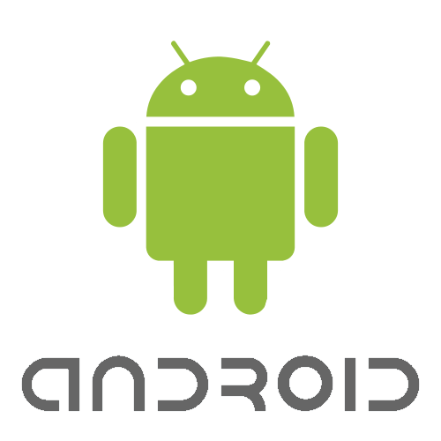­­

# What is Android?

[Operating Systems](http://www.engineersgarage.com/articles/operating-systems-tutorial) have developed a lot in last 20 years. Starting from black and white phones to recent smart phones or mini computers, mobile OS has come far away. Especially for smart phones, Mobile OS has greatly evolved from Palm OS in 1996 to Windows pocket PC in 2000 then to Blackberry OS and Android.

 One of the most widely used mobile OS these days is **ANDROID**. **Android** is a software bunch comprising not only operating system but also middleware and key applications. Android Inc was founded in Palo Alto of California, U.S. by Andy Rubin, Rich miner, Nick sears and Chris White in 2003. Later Android Inc. was acquired by Google in 2005. After original release there have been number of updates in the original version of Android. The current stable version is [Android 10](https://en.wikipedia.org/wiki/Android_10), released on September 3, 2019.

## Features

* **Application framework** enabling reuse and replacement of components
* **Dalvik virtual machine** optimized for mobile devices
* **Integrated browser** based on the open source WebKit engine
* **Optimized graphics** powered by a custom 2D graphics library; 3D graphics based on the OpenGL ES 1.0 specification (hardware acceleration optional)
* **SQLite** for structured data storage
* **Media support** for common audio, video, and still image formats (MPEG4, H.264, MP3, AAC, AMR, JPG, PNG, GIF)
* **GSM Telephony** (hardware dependent)
* **Bluetooth, EDGE, 3G, and WiFi** (hardware dependent)
* **Camera, GPS, compass, and accelerometer** (hardware dependent)
* **Rich development environment** including a device emulator, tools for debugging, memory and performance profiling, and a plugin for the Eclipse IDE.

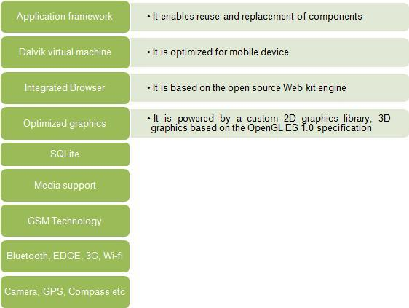

## Android Architecture

The following diagram shows the major components of the Android operating system. Each section is described in more detail below.

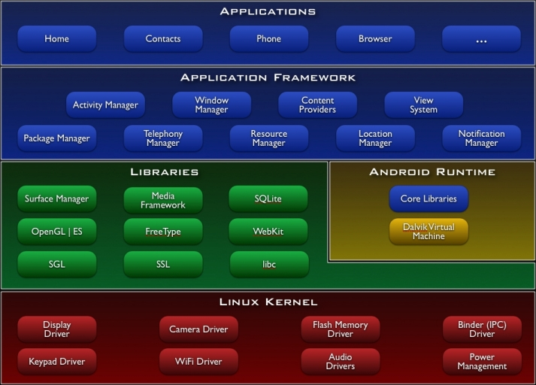

**Applications**

World is contracting with the growth of mobile phone technology. As the number of users is increasing day by day, facilities are also increasing. Starting with simple regular handsets which were used just for making phone calls, mobiles have changed our lives and have become part of it. Now they are not used just for making calls but they have innumerable uses and can be used as a Camera , Music player, Tablet PC, T.V. , Web browser etc . And with the new technologies, new software and operating systems are required.

## Application Framework

By providing an open development platform, Android offers developers the ability to build extremely rich and innovative applications. Developers are free to take advantage of the device hardware, access location information, run background services, set alarms, add notifications to the status bar, and much, much more.

Developers have full access to the same framework APIs used by the core applications. The application architecture is designed to simplify the reuse of components; any application can publish its capabilities and any other application may then make use of those capabilities (subject to security constraints enforced by the framework). This same mechanism allows components to be replaced by the user.

Underlying all applications is a set of services and systems, including:

* A rich and extensible set of Views that can be used to build an application, including lists, grids, text boxes, buttons, and even an embeddable web browser
* Content Providers that enable applications to access data from other applications (such as Contacts), or to share their own data
* A Resource Manager, providing access to non-code resources such as localized strings, graphics, and layout files
* A Notification Manager that enables all applications to display custom alerts in the status bar
* An Activity Manager that manages the lifecycle of applications and provides a common navigation back stack

## Libraries

Android includes a set of C/C++ libraries used by various components of the Android system. These capabilities are exposed to developers through the Android application framework. Some of the core libraries are listed below:

* **System C library** - a BSD-derived implementation of the standard C system library (libc), tuned for embedded Linux-based devices
* **Media Libraries** - based on PacketVideo'sOpenCORE; the libraries support playback and recording of many popular audio and video formats, as well as static image files, including MPEG4, H.264, MP3, AAC, AMR, JPG, and PNG
* **Surface Manager** - manages access to the display subsystem and seamlessly composites 2D and 3D graphic layers from multiple applications
* **LibWebCore** - a modern web browser engine which powers both the Android browser and an embeddable web view
* **SGL** - the underlying 2D graphics engine
* **3D libraries** - an implementation based on OpenGL ES 1.0 APIs; the libraries use either hardware 3D acceleration (where available) or the included, highly optimized 3D software rasterizer
* **FreeType** - bitmap and vector font rendering
* **SQLite** - a powerful and lightweight relational database engine available to all applications

## Android Runtime

Android includes a set of core libraries that provides most of the functionality available in the core libraries of the Java programming language.

Every Android application runs in its own process, with its own instance of the Dalvik virtual machine. Dalvik has been written so that a device can run multiple VMs efficiently. The Dalvik VM executes files in the Dalvik Executable (.dex) format which is optimized for minimal memory footprint. The VM is register-based, and runs classes compiled by a Java language compiler that have been transformed into the .dex format by the included "dx" tool.

The Dalvik VM relies on the Linux kernel for underlying functionality such as threading and low-level memory management.

## Linux Kernel

Android relies on Linux version 2.6 for core system services such as security, memory management, process management, network stack, and driver model. The kernel also acts as an abstraction layer between the hardware and the rest of the software stack.

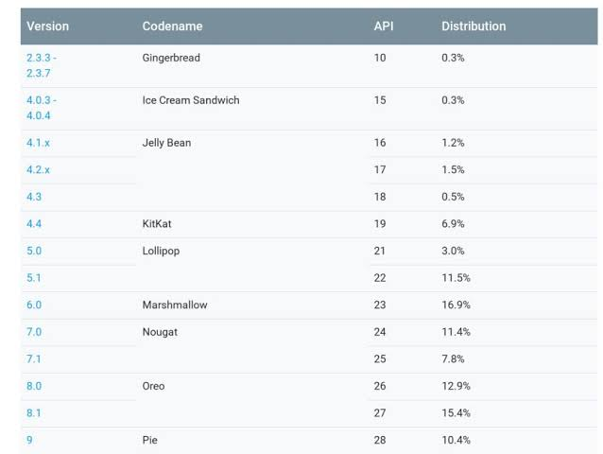

Android versions.

**Android Devices in the Market**

Android devices come in all shapes and sizes. As of late November 2011, the Android OS powers the

following types of devices:

* Smartphones
* Tablets
* E-reader devices
* Netbooks
* MP4 players
* Internet TVs

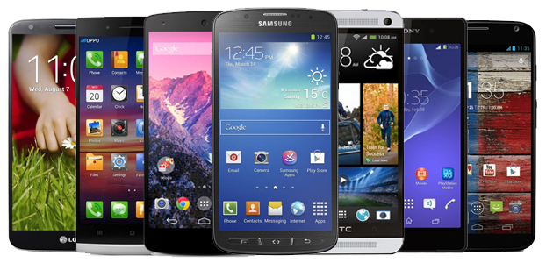

**2.2 JAVA**

Java is a general purpose and the most popular object-oriented programming language. Java was developed by James Gosling and his colleagues at Sun Microsystems in the early 1990’s.

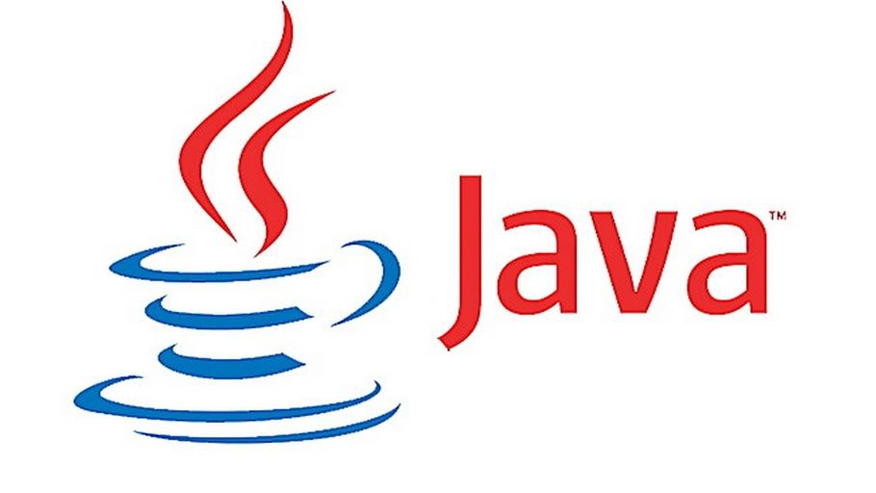

Due to its simplicity and easy to learn and advanced features, we opted this language for our six months industrial training. This language supports many interesting features that make it an ideal language for software development. In addition to the object oriented features, it also provides features such as platform independence, security, multithreading, portability; etc which makes it well suited for the web and networked services, applications, platform-independent desktops, robotics and any other embedded devices*.*

**Features of Java**

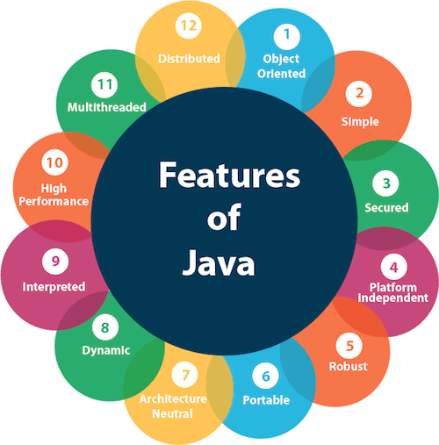

* **Simple**: Java is a compact and simple language. Programs are easy to write and debug as it omits many clumsy, poorly understood and confusing features of other programming languages such as C++.
* **Object-oriented:** Java is purely object-oriented language because programming in java is centered on creating objects; manipulating objects and making objects work together.
* **Distributed:** Java is a distributed language which means that the programs can be designed to run on computer networks. Java provides an extensive library of classes for communicating using TCP/IP protocols such as HTTP and FTP. This makes creating network connections much easier.
* **Robust:** Java is designed for writing programs that are highly robust. By robust, we mean reliable.
* **Secure:** As java is intended to be used in networked/distributed environments so it implements several security mechanisms to protect you against malicious code that might try to invade your file system.
* **Architectural Neutral:** This means that the programs written on one platform can run on any other platform without having to rewrite or recompile them. It follows ‘Write-once-run-anywhere’ approach.
* **Portable:** In Java, the size of the primitive data types is machine independent. These consistencies make java program portable among different platforms such as Windows, UNIX and Mac.
* **Interpreted:** Java is such a language that is both compiled and interpreted. The two steps of compilation and interpretation allow extensive code checking and improved security.
* **High performance:** Java programs are complied with portable intermediate form known as byte codes, rather than to native machine level instructions and JVM executes java byte codes on any machine on which it is installed. This architecture means that java programs are faster.
* **Multithreaded:** Java is also a multithreaded programming language. It allows you to write a program that can do many tasks simultaneously.
* **Dynamic:** Java is designed to be dynamic. Classes are stored in separate files and are loaded into the Java Interpreter only when they are needed.
* **Platform Independent:** Java is platform independent. Because the Java compiler converts the source code to bytecode, which is Intermidiate Language. Bytecode can be executed on any platform (OS) using JVM( Java Virtual Machine).

**JAVA DEVELOPMENT KIT (JDK)**

The Java Development Kit (JDK) is a software package that sun has made available to public. It includes all the basic components that makeup the java environment. These include the Java compiler, Java Interpreter, an applet viewer that lets you see applets without opening a Java-compatible web browser.

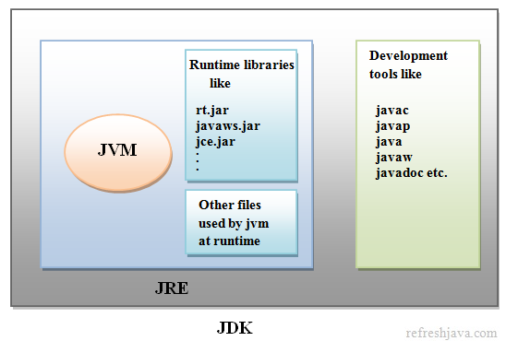

**APPLICATIONS OF JAVA**

Java has evolved from a simple language providing interactive dynamic content for webpage’s to a predominant enterprise-enables programming language suitable for developing significant and critical applications.

Today, Java is used for many applications like:

* Web based applications
* Financial applications
* Gaming applications
* Embedded applications
* Distributed enterprise applications
* Mobile applications
* Image applications
* E-business applications
* Desktop applications and many more.

**SOCKET PROGRAMMING IN JAVA**

Clients and Servers establish connections and communicate via sockets. Connections are the communication links that are created over the Internet using TCP. Some client/server applications are also building around the connectionless UDP. These applications also use sockets to communicate.

**A Socket is an abstraction through which an application, may send and receive data.**

There are two types of sockets used in socket programming in java:

* **Stream Socket:** A Stream Socket is a connection oriented socket. Thus a connection has to be established before it can send or receive data. Data that one end of the connection writes to the socket is available for reading at the other end of the socket connection. The Stream Sockets use TCP protocol for data transmission.
* **Datagram Socket:** Datagram Socket is a connectionless socket, thus no actual connection is established between two communicating hosts. The datagram socket use UDP protocol for data transmission. Since UDP does not guarantee that all packets are received in the correct order or not. Also with UDP the packets can even be lost or dispatched.
* **Raw Sockets:** Some protocols such as ICMP or OSPF that directly us the services of IP, use neither stream nor datagram sockets. Raw Sockets are designed for these types of applications.

**The java.net package contains fundamental classes for communication and working with network resources.**

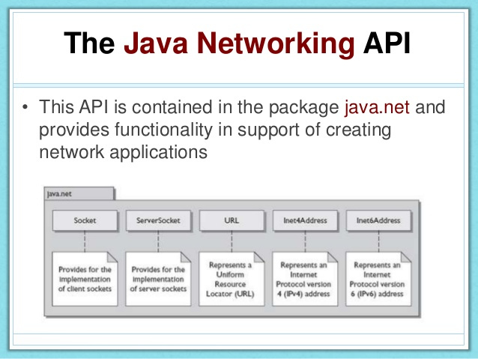

**2.3 JSP**

**Java Server Pages (JSP)**

Java Server Pages (JSP) is a server-side programming technology that enables the creation of dynamic, platform-independent method for building Web-based applications. JSP have access to the entire family of Java APIs, including the JDBC API to access enterprise databases. This tutorial will teach you how to use Java Server Pages to develop your web applications in simple and easy steps.

Basically, any html file can be converted to JSP file by just changing the file extension from “.html” to “.jsp”, it would run just fine. What differentiates JSP from HTML is the ability to use java code inside HTML. In JSP, you can embed Java code in HTML using JSP tags. for e.g. run the code below, every time you run this, it would display the current time. That is what makes this code dynamic.

JSP technology is used to create dynamic web applications. JSP pages are easier to maintain then a Servlet. JSP pages are opposite of Servlets as a servlet adds HTML code inside Java code, while JSP adds Java code inside HTML using JSP tags. Everything a Servlet can do, a JSP page can also do it.

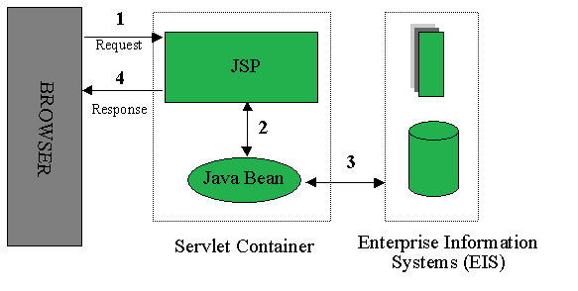

JSP enables us to write HTML pages containing tags, inside which we can include powerful Java programs. Using JSP, one can easily separate Presentation and Business logic as a web designer can design and update JSP pages creating the presentation layer and java developer can write server side complex computational code without concerning the web design. And both the layers can easily interact over HTTP requests.

**Advantages of JSP:**

* Easy to maintain and code.
* High Performance and Scalability.
* JSP is built on Java technology, so it is platform independent.

**2.4 SQL**

SQL stands for Structured Query Language. SQL is a standard language for accessing and manipulating databases.

* SQL can execute queries against a database
* SQL can retrieve data from a database
* SQL can insert records in a database
* SQL can update records in a database
* SQL can delete records from a database
* SQL can create new databases
* SQL can create new tables in a database
* SQL can create stored procedures in a database
* SQL can create views in a database
* SQL can set permissions on tables, procedures, and views.

To build a web site that shows data from a database, you will need:

* An RDBMS database program (i.e. MS Access, SQL Server, MySQL)
* To use a server-side scripting language, like PHP or JSP
* To use SQL to get the data you want
* To use HTML / CSS to style the page

**CHAPTER 3**

**SNAPSHOTS**

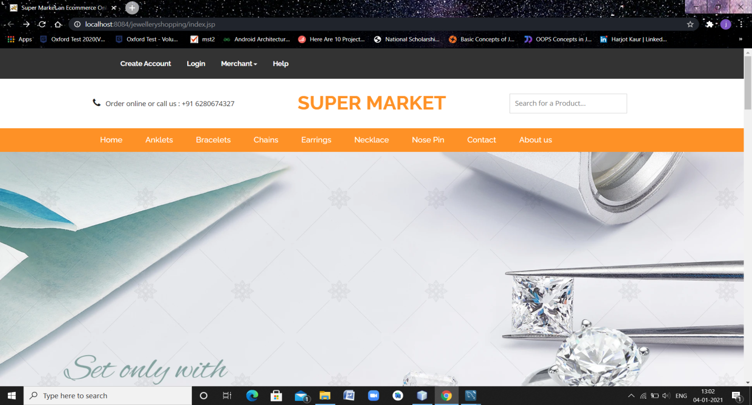

**Fig: 3.1 Index Page**

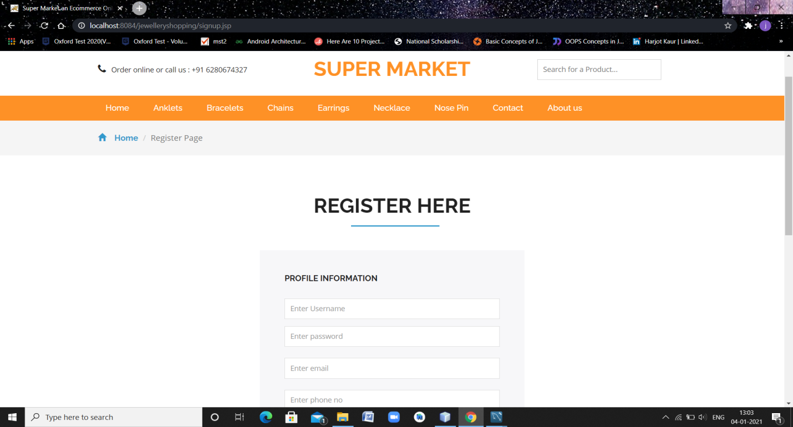**Fig: 3.2 Customer Register Page**

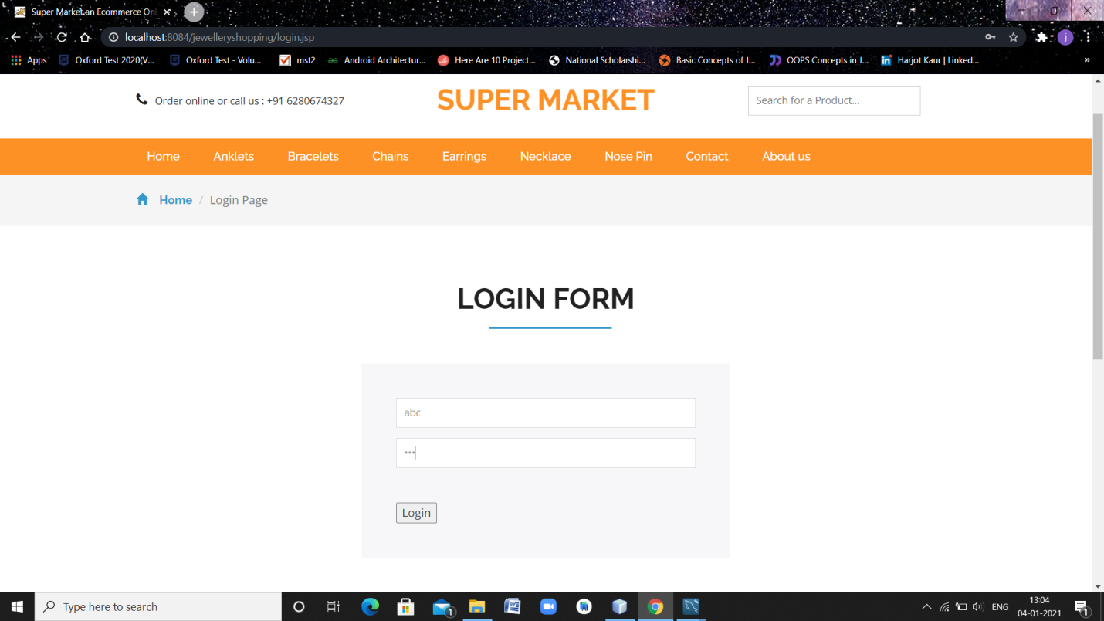**Fig: 3.3 Customer Login Page**

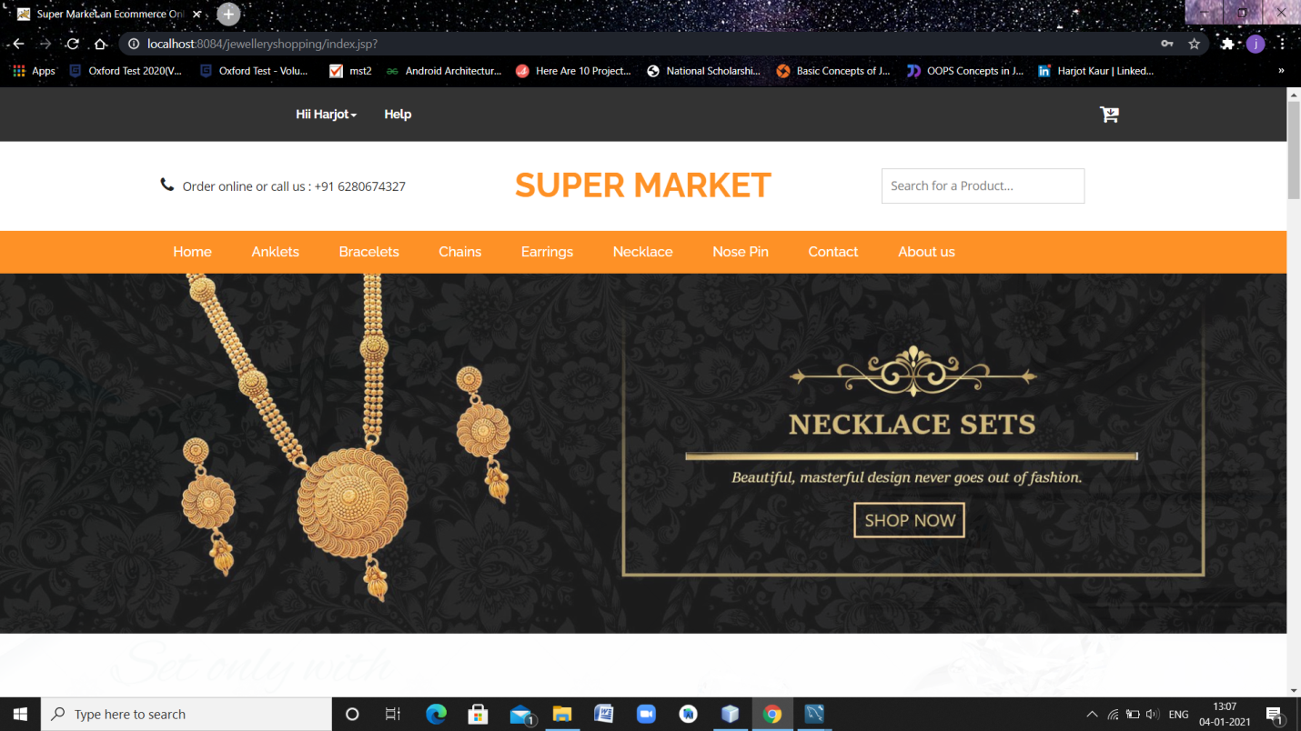**Fig: 3.4 Home Page**

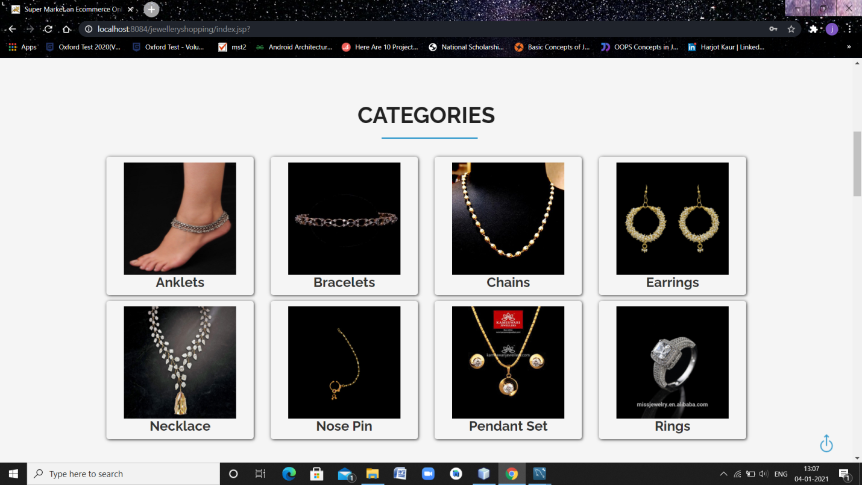

**Fig: 3.5 View all Categories**

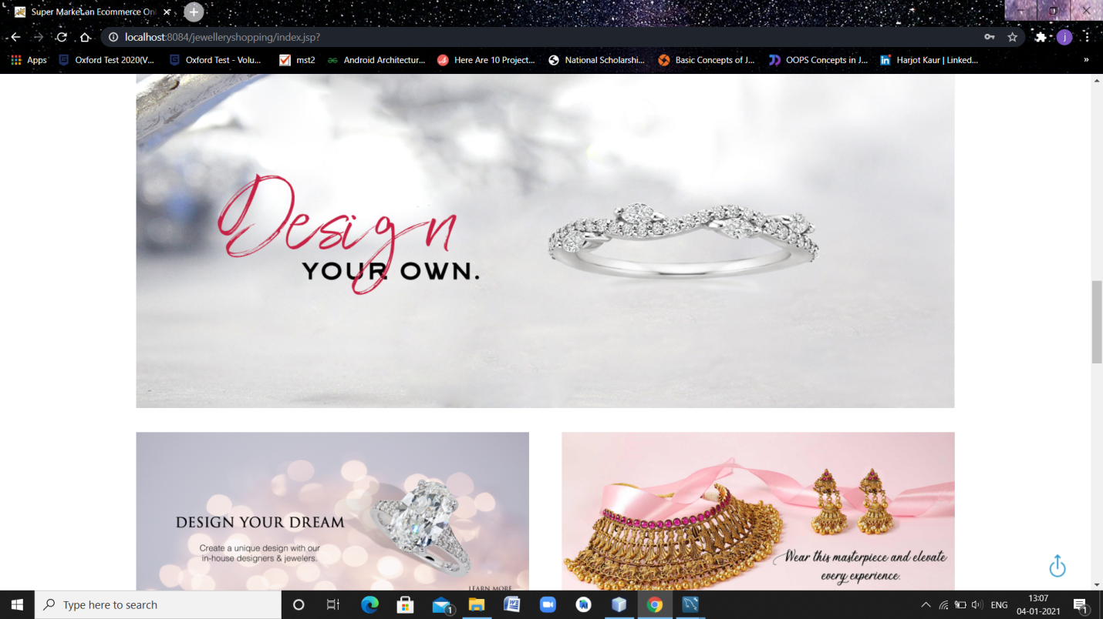

**Fig: 3.6 Banners**

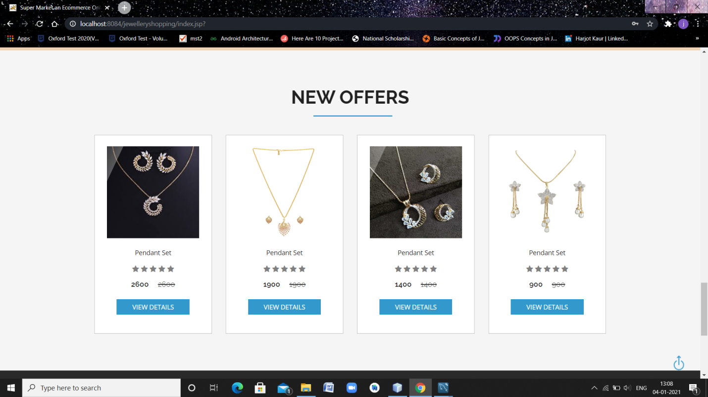

**Fig: 3.7 New Offers Page**

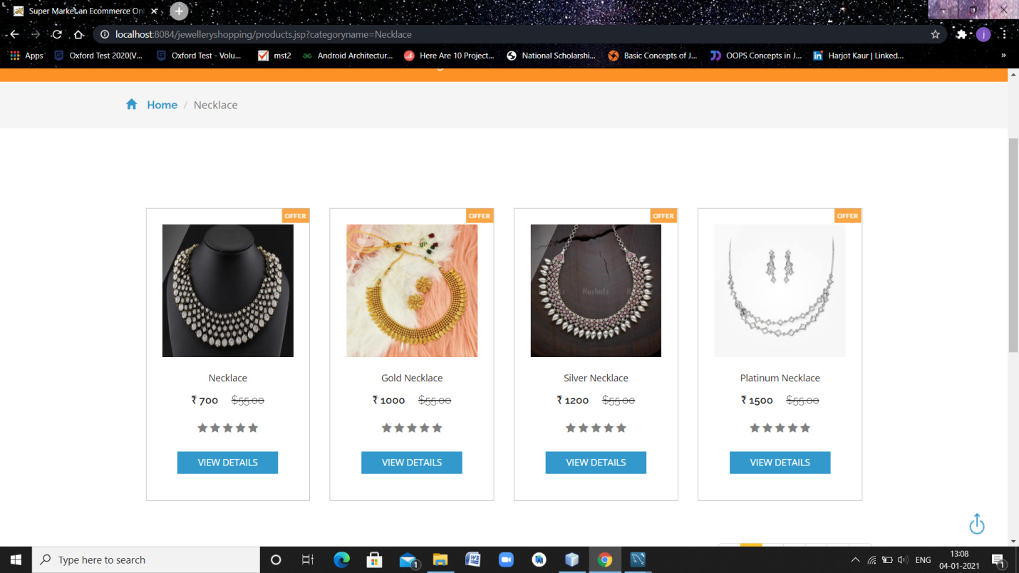

**Fig: 3.8 View all Products**

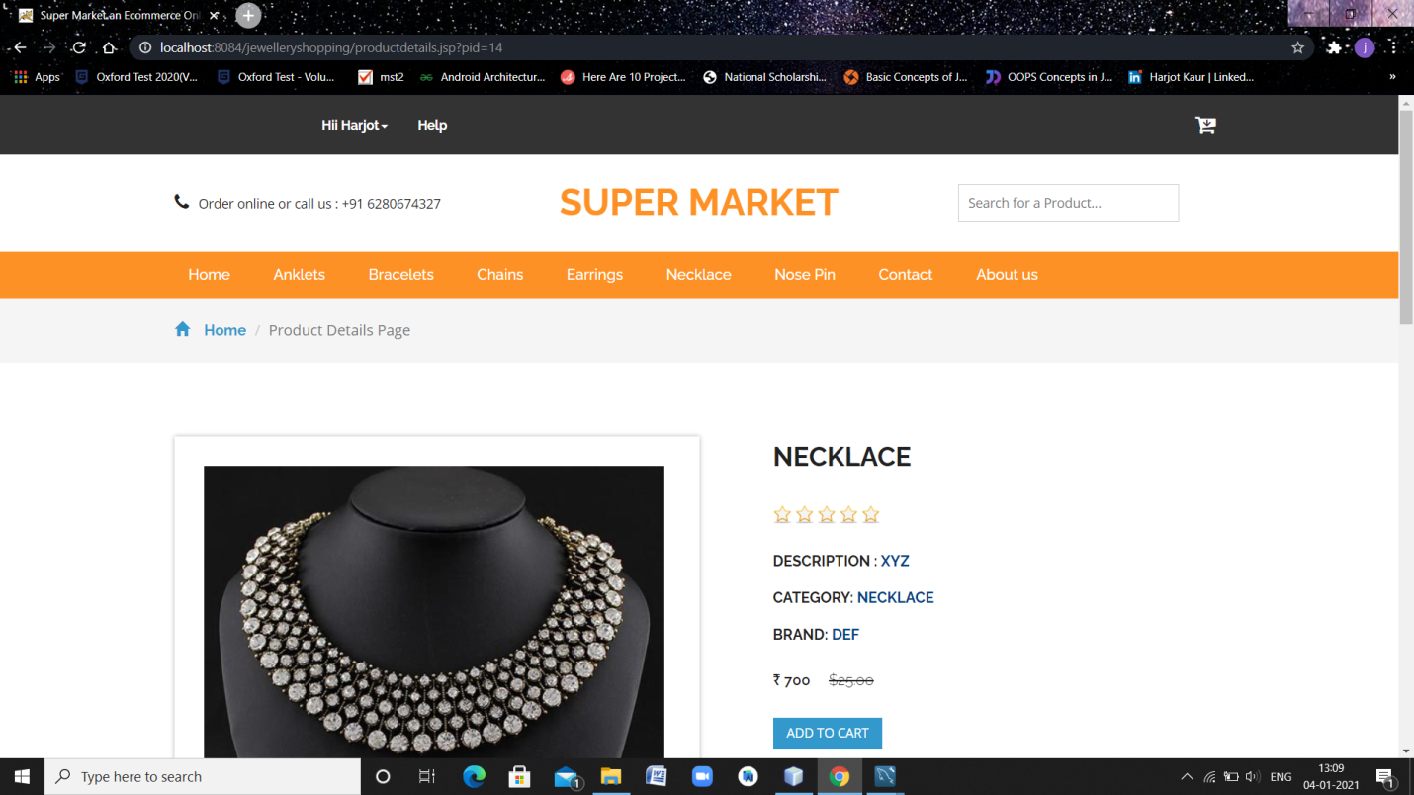

**Fig: 3.9 Products Detail Page**

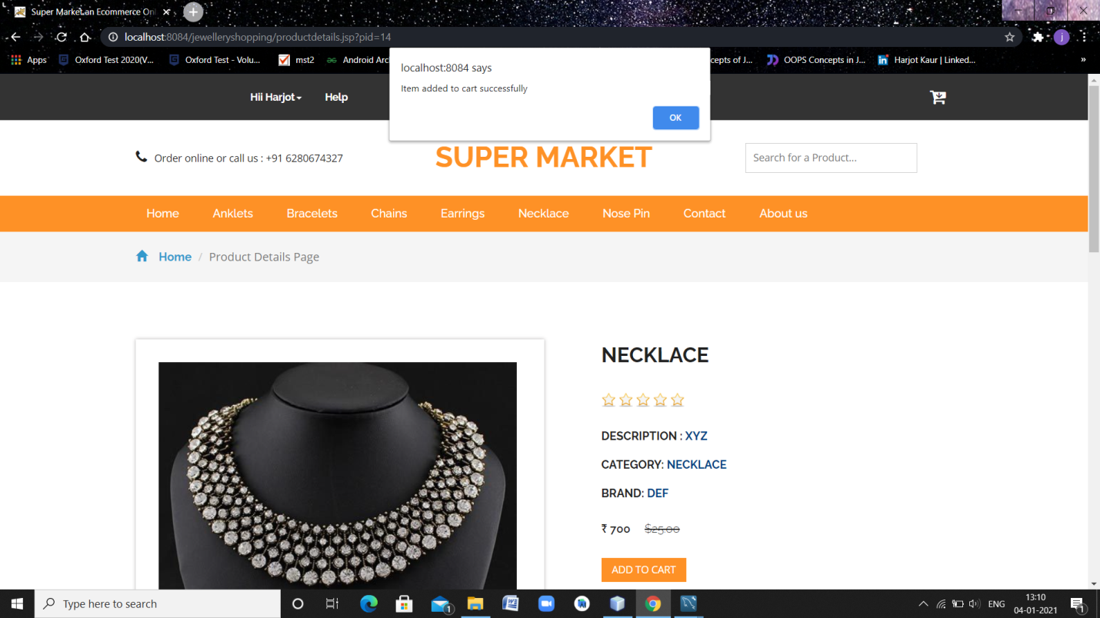

**Fig: 3.10 Add to Cart**

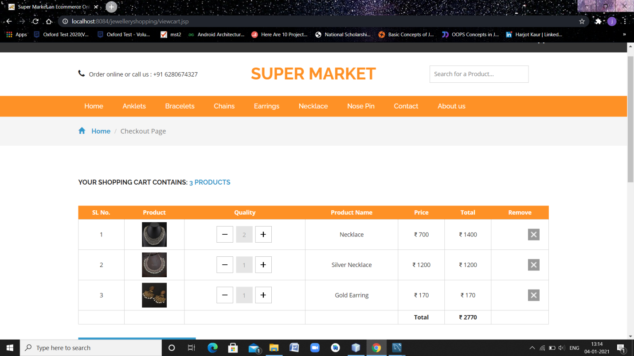

**Fig: 3.11 Checkout Page**

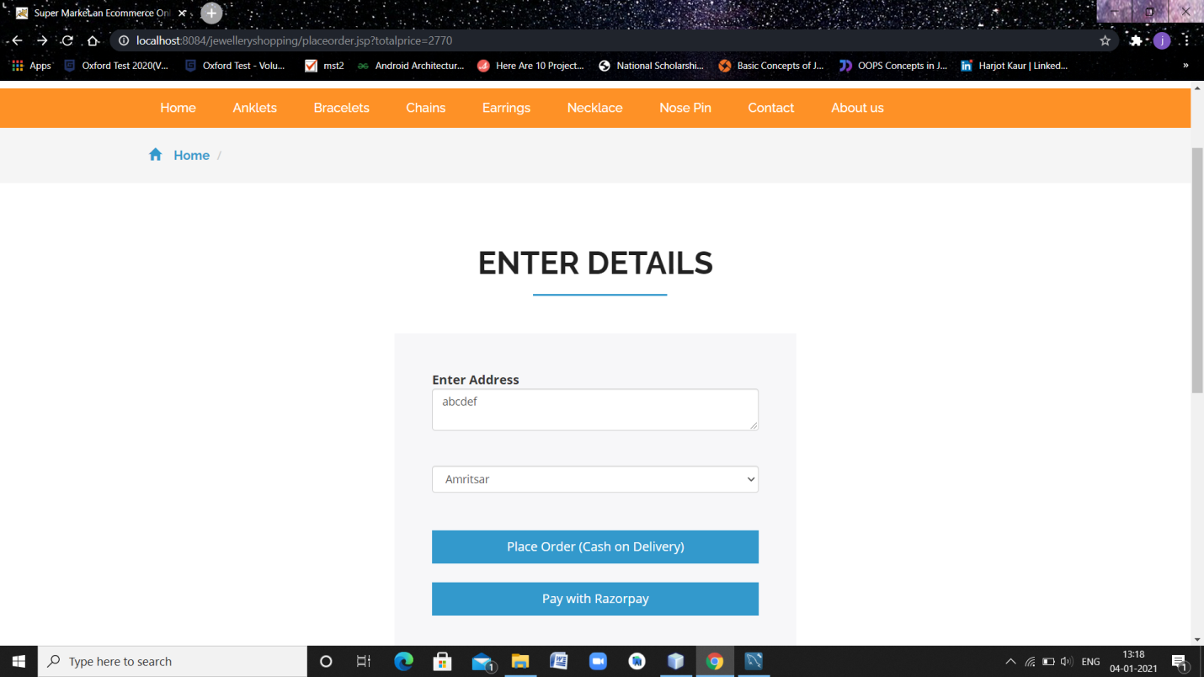**Fig: 3.12 Payment Option Page**

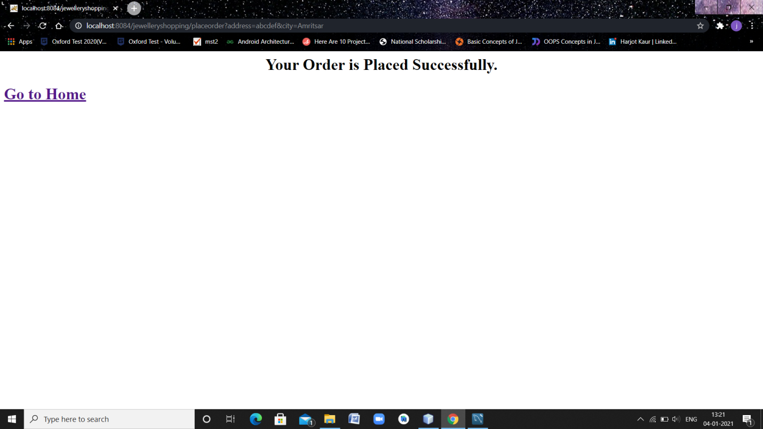**Fig: 3.13 Order Placed Successfully Page**

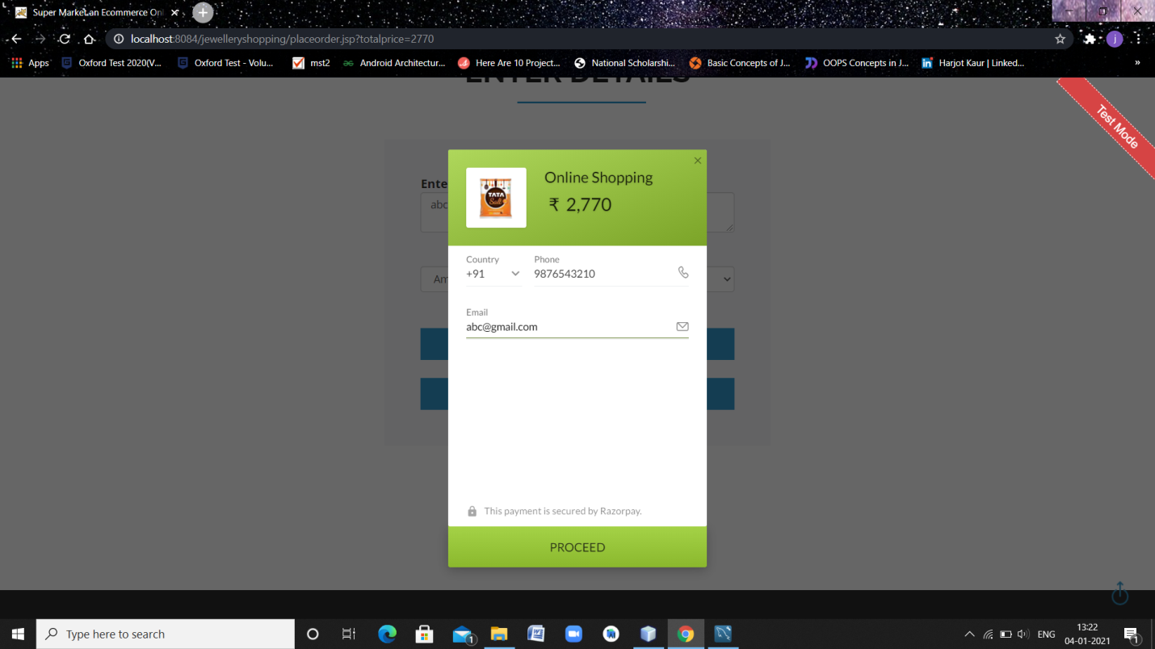**Fig: 3.14 Online Payment Option Page**

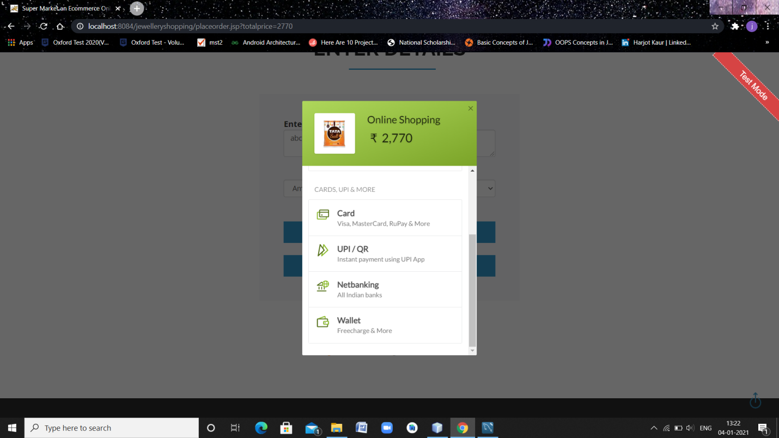 **Fig: 3.15 Select Cards, UPI & More Payment Option Page**

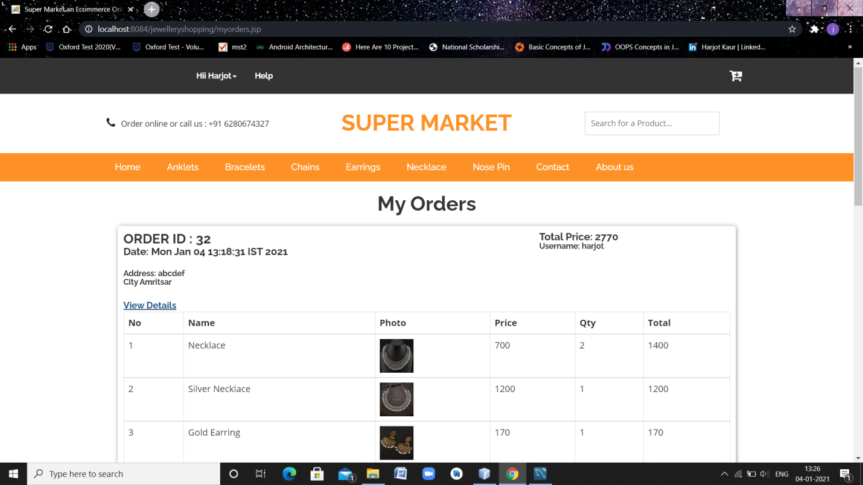**Fig: 3.16 My Orders Page**

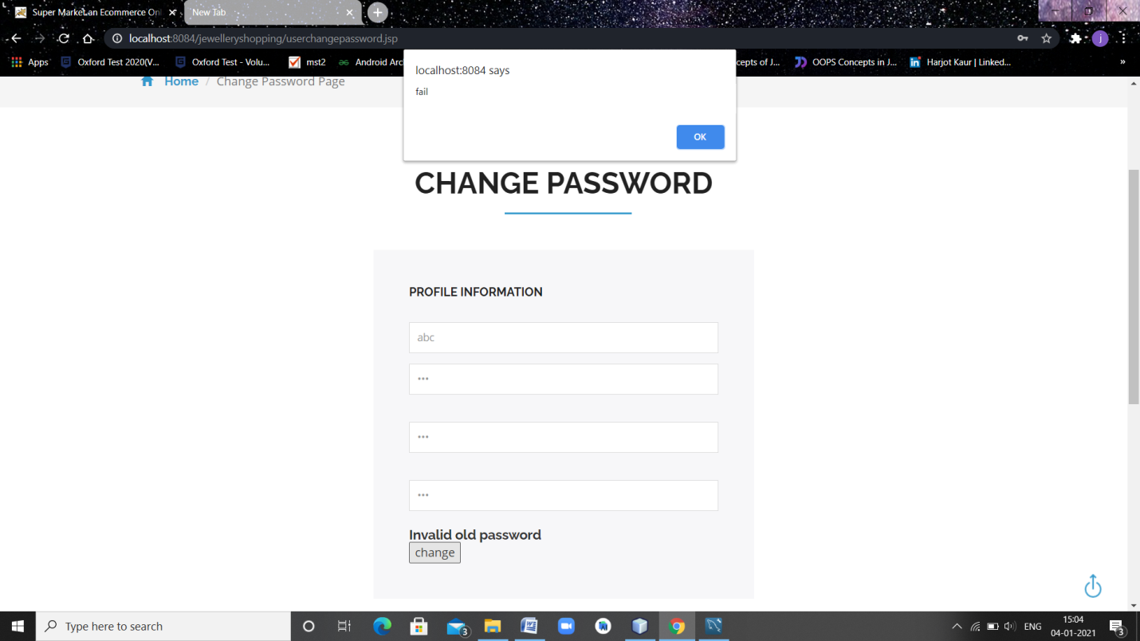

**Fig: 3.17 Validations for Wrong Credentials**

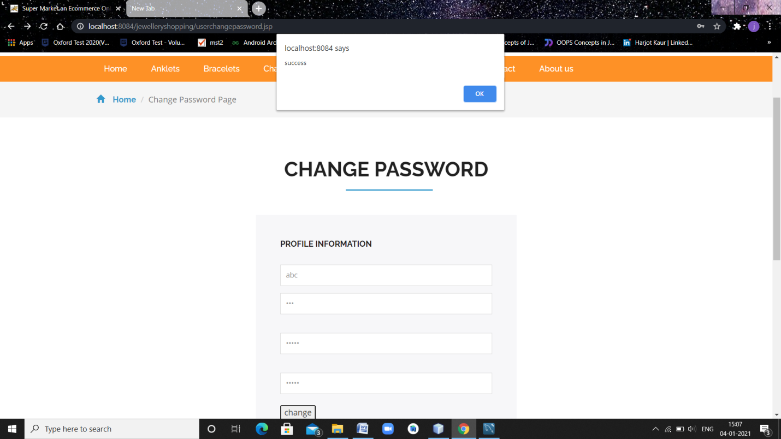

**Fig: 3.18 Change Password Page**

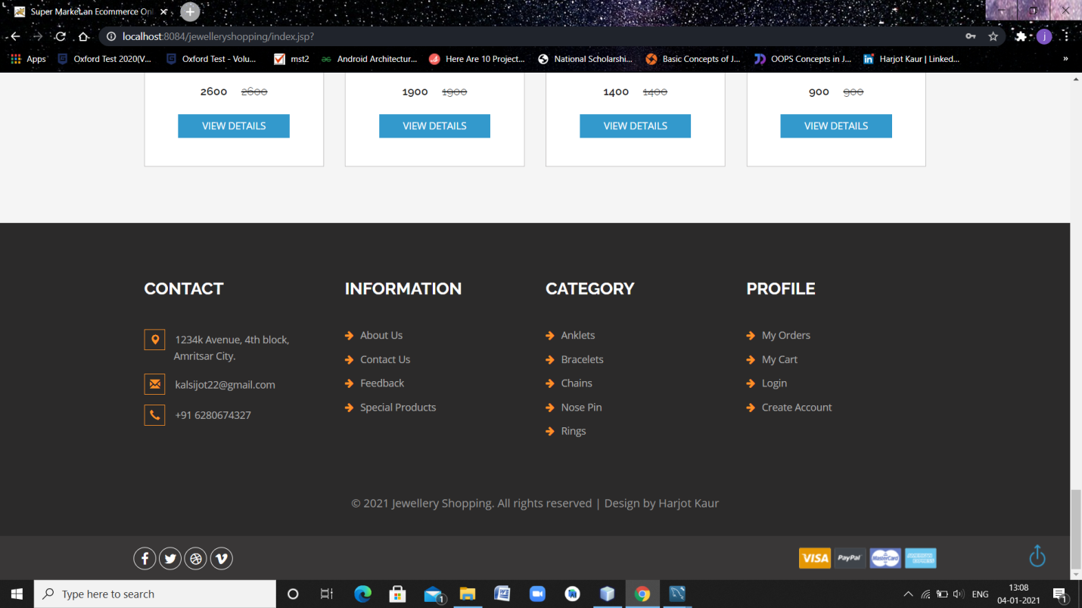

**Fig: 3.19 Footer Page**

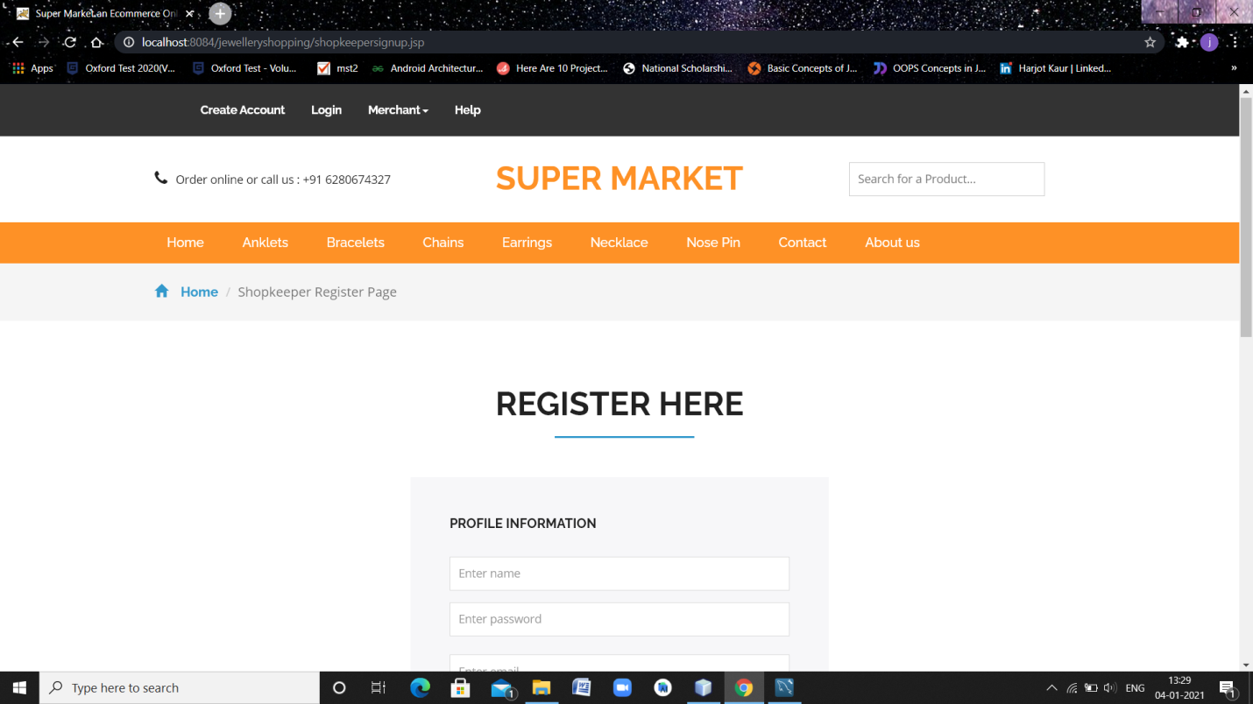

**Fig: 3.20 Merchant Register Page**

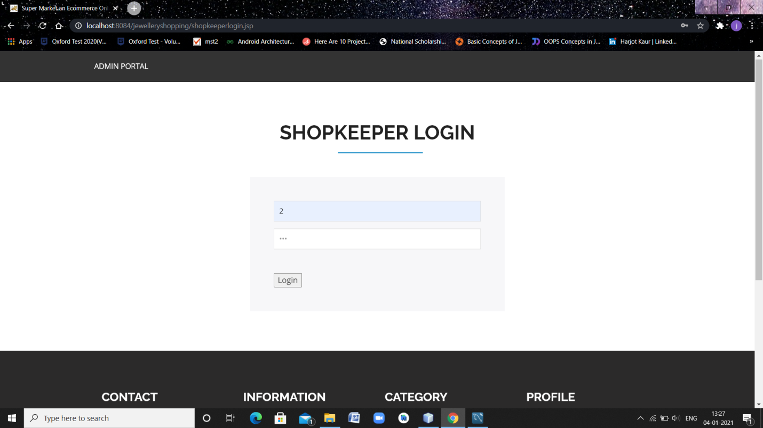

**Fig: 3.21 Merchant Login Page**

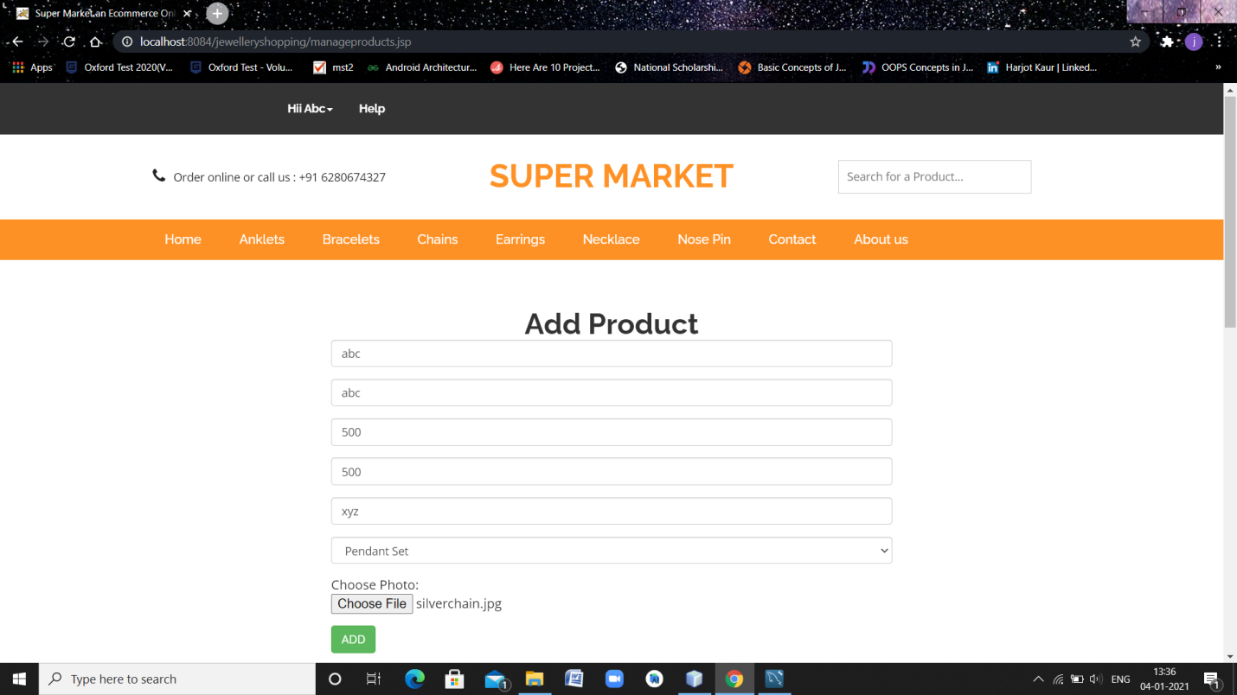

**Fig: 3.22 Add new Product’s Option Page**

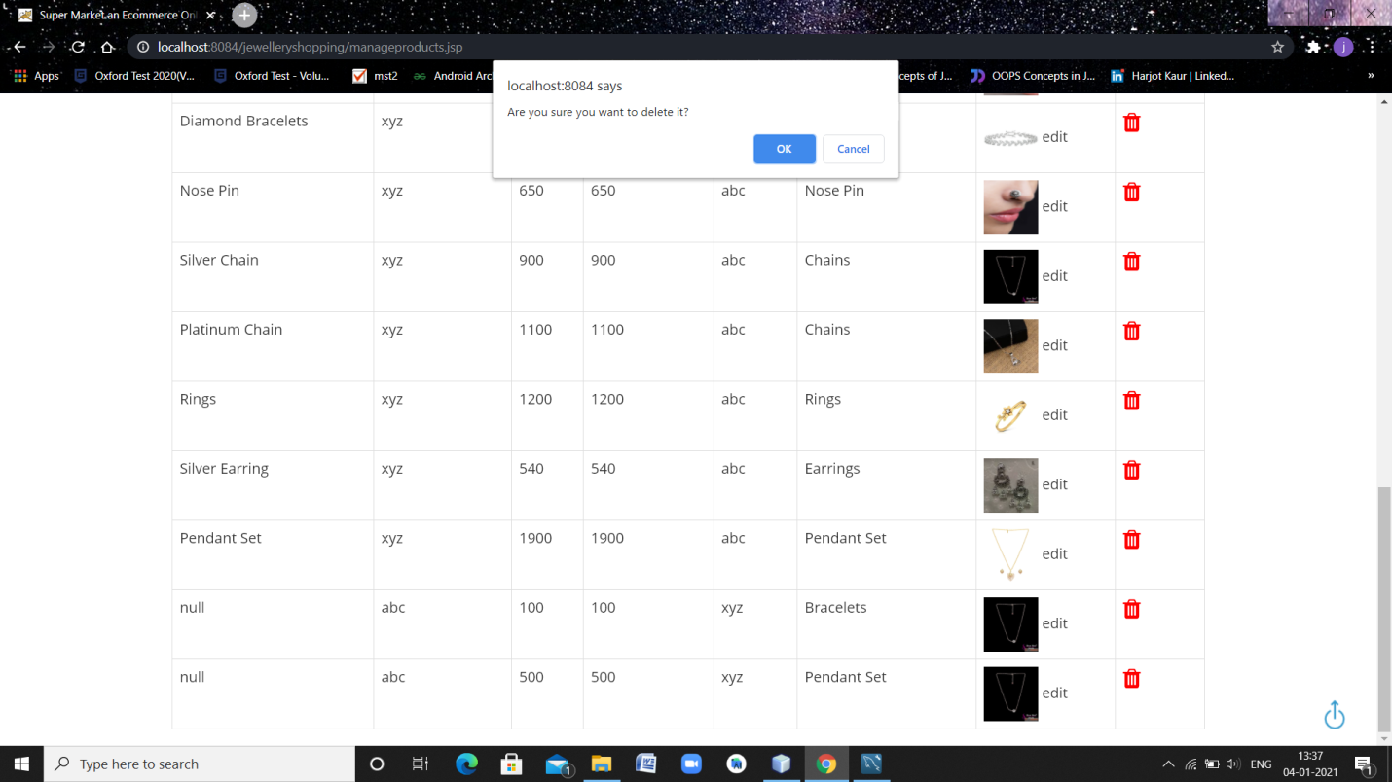**Fig: 3.23 Delete Product’s Page**

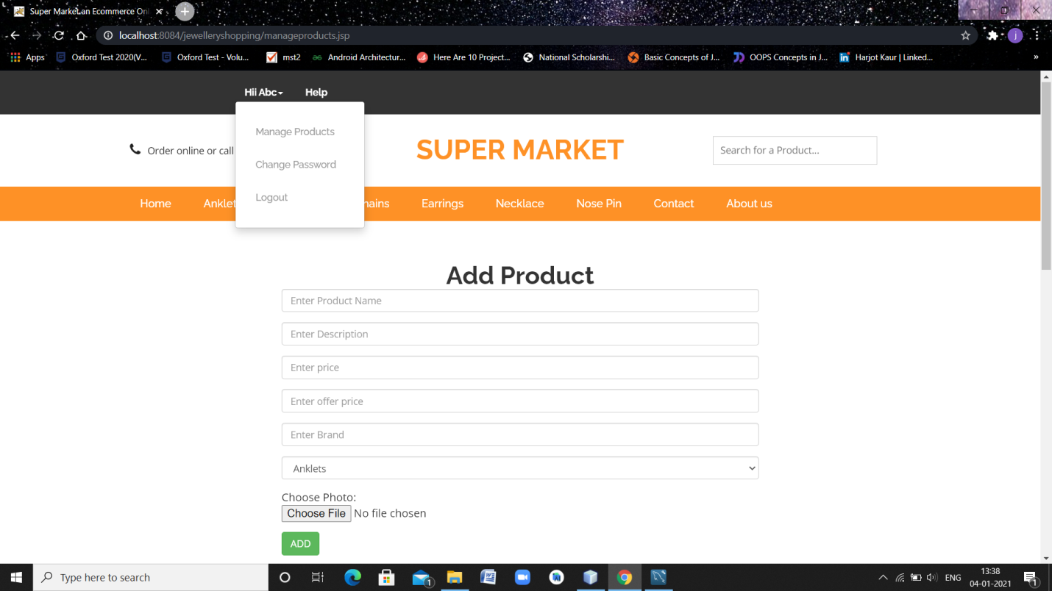**Fig: 3.24 Merchant Logout Option**

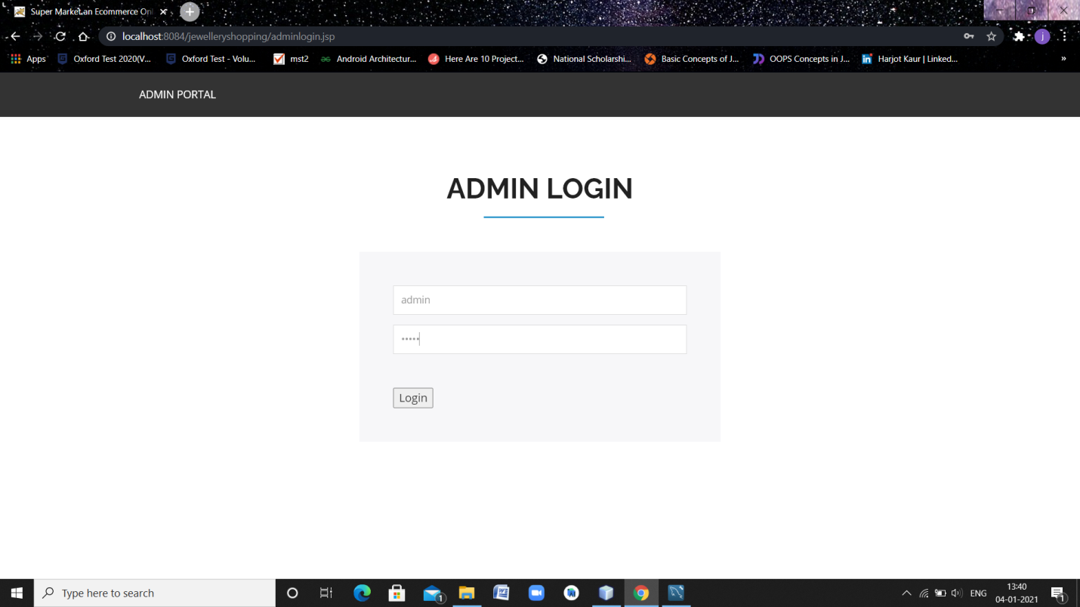

**Fig: 3.25 Admin Login Page**

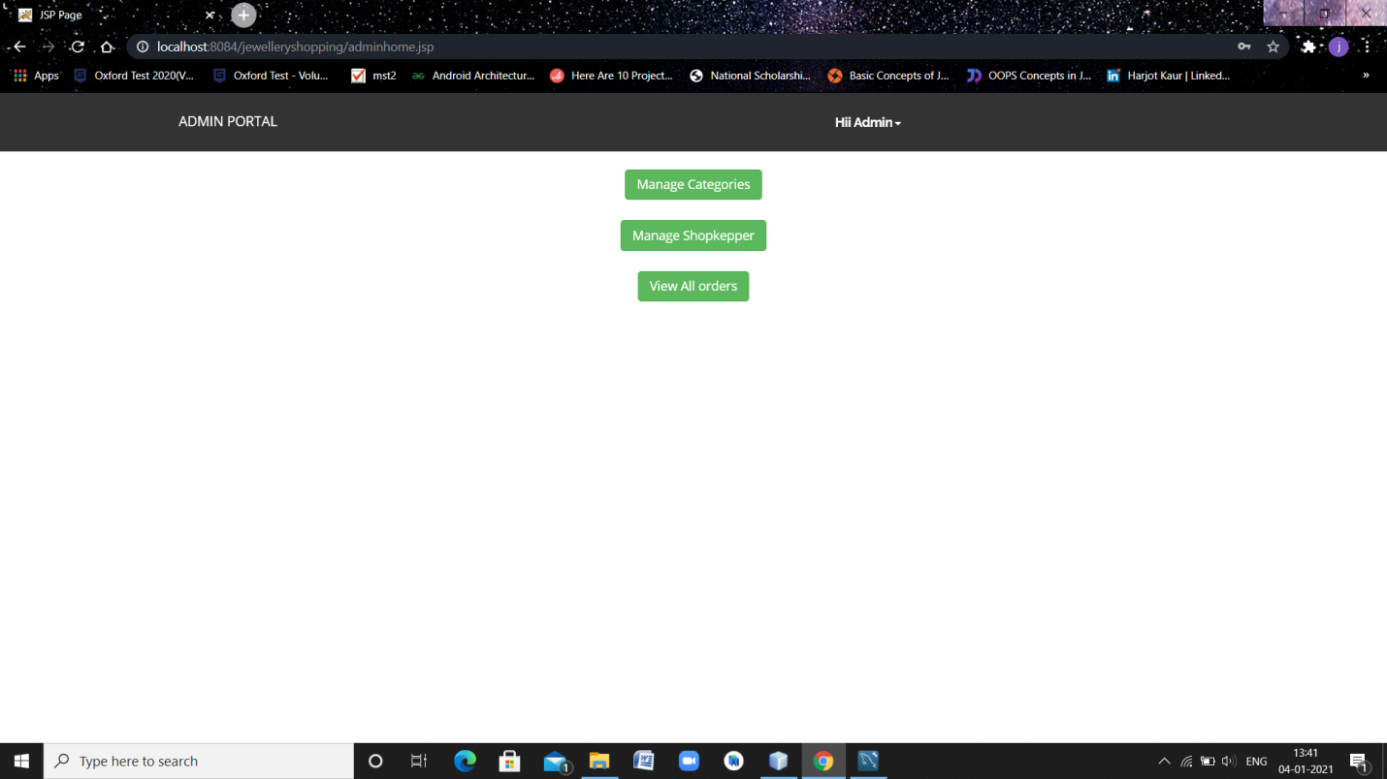

**Fig: 2.26 Admin Home Page**

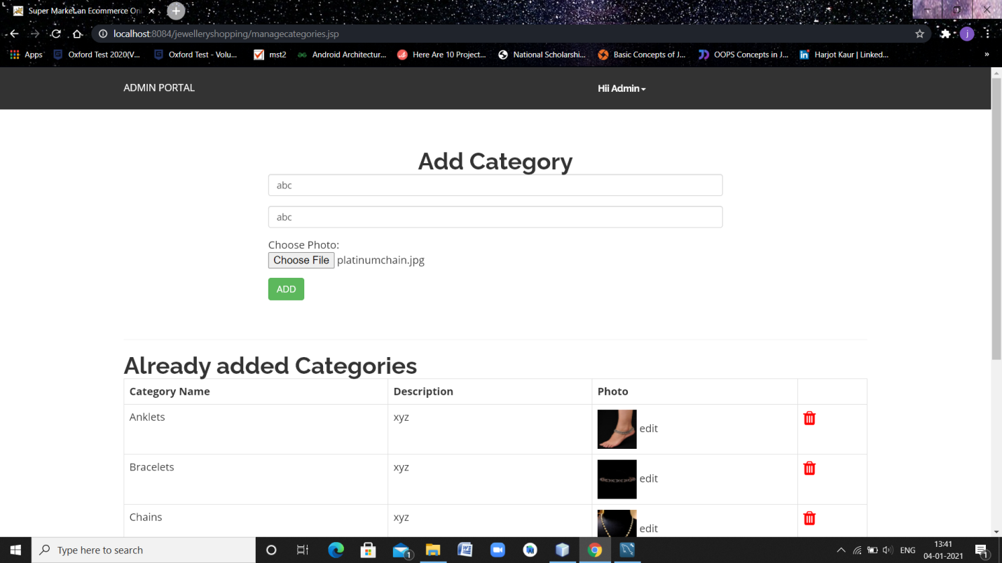

**Fig:3.27 Add Category Page**

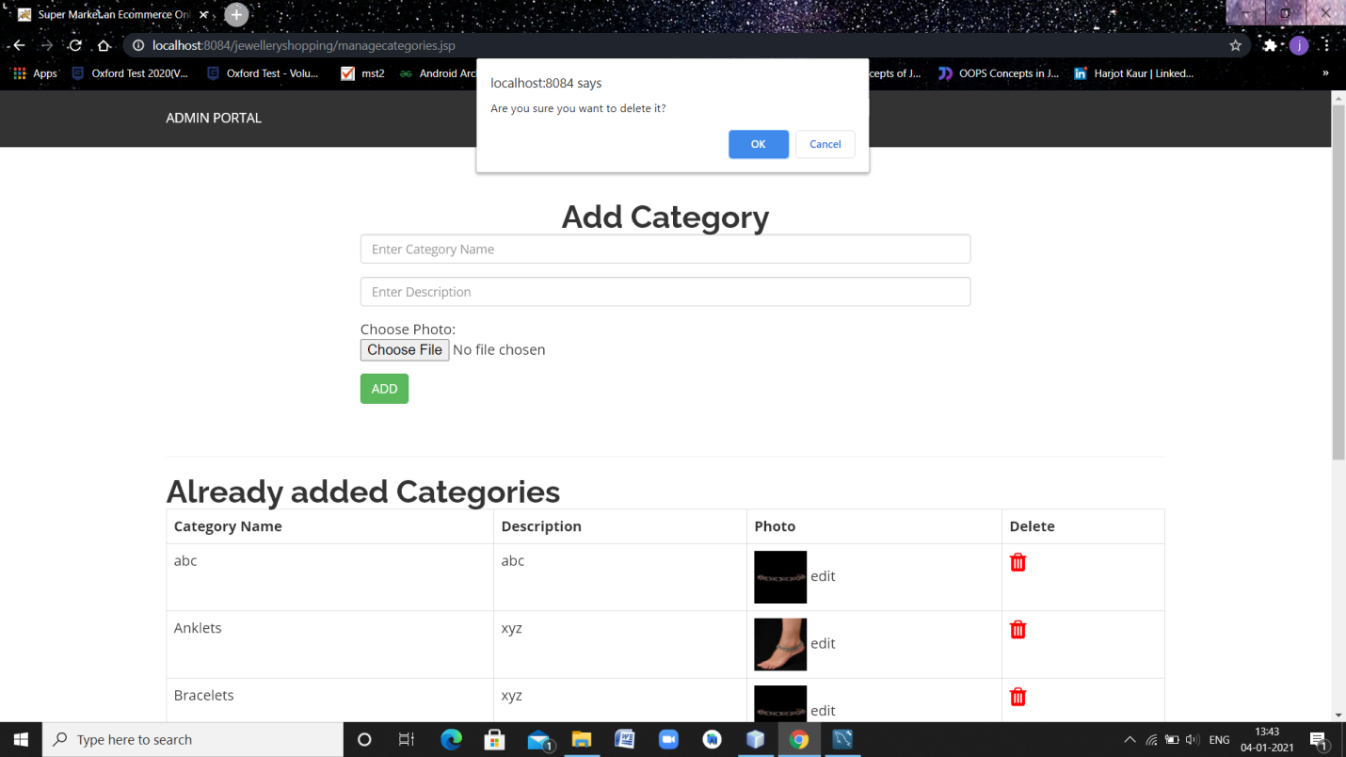

**Fig: 3.28 Delete Category Page**

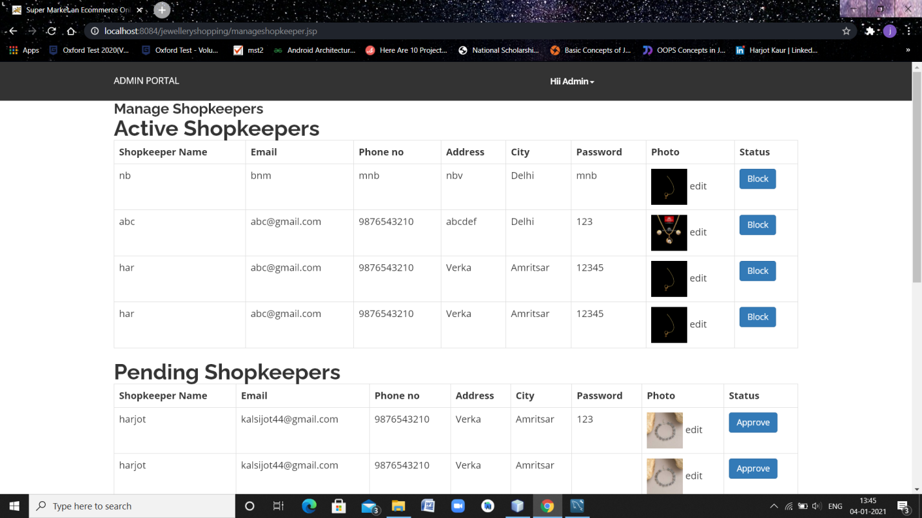

**Fig: 3.29 Manage Merchants page**

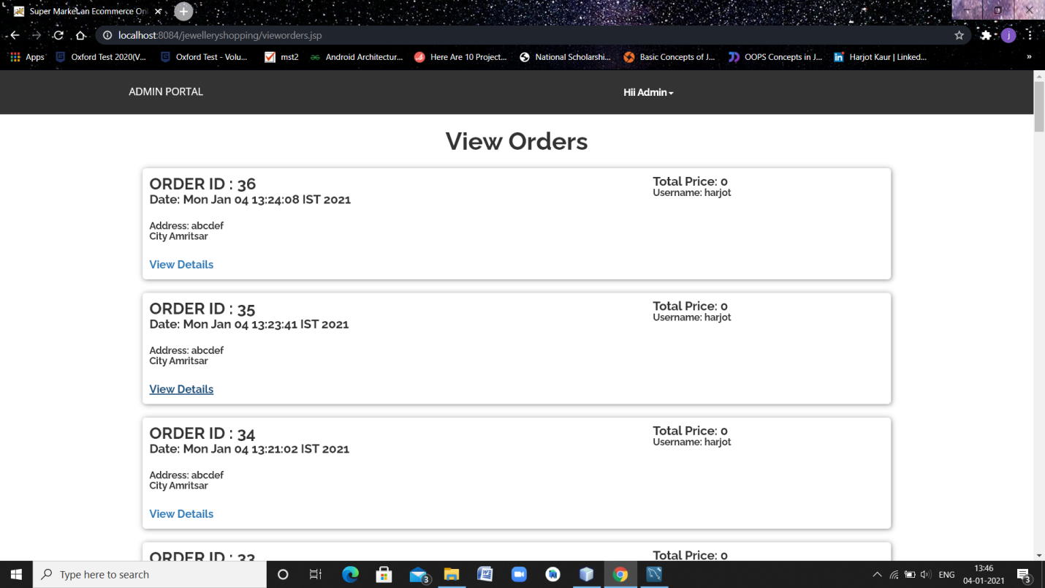

**Fig: 3.30 View All Orders**

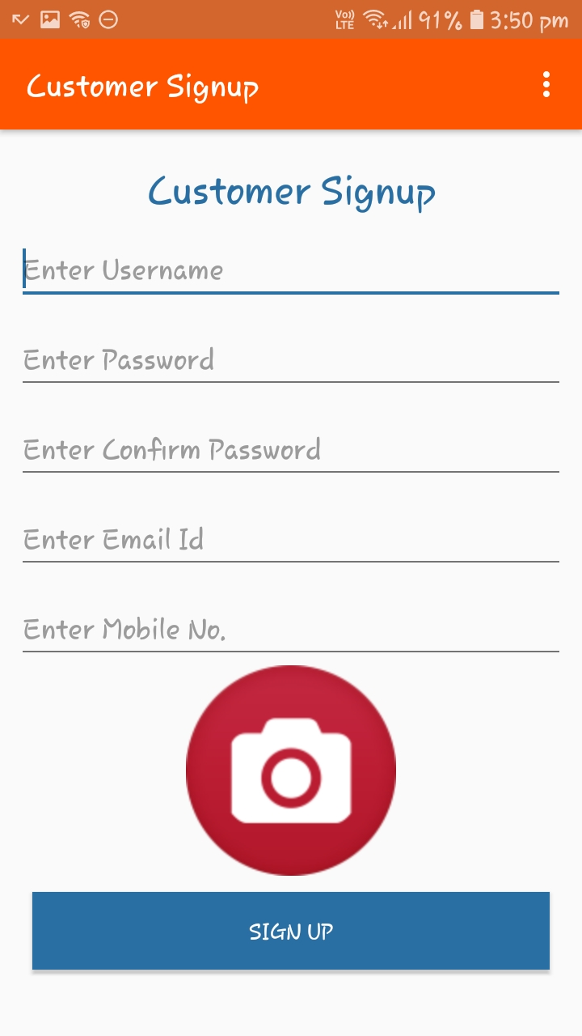

**Fig: 3.31 Customer Signup Page**

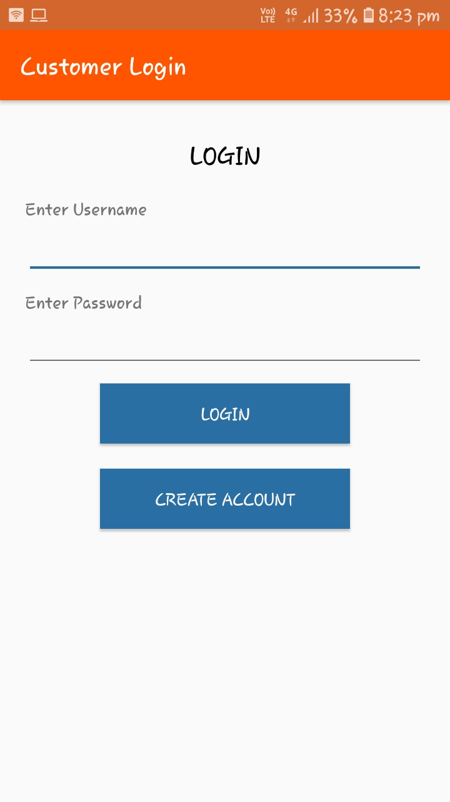

**Fig: 3.32 Customer Login Page**

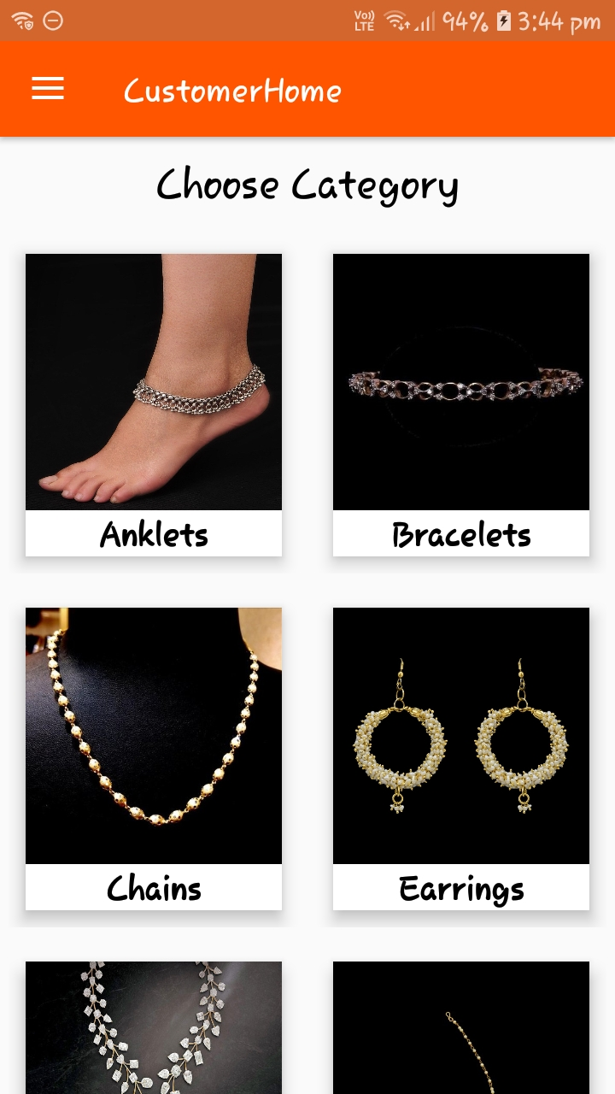

**Fig: 3.33 View all Categories Page**

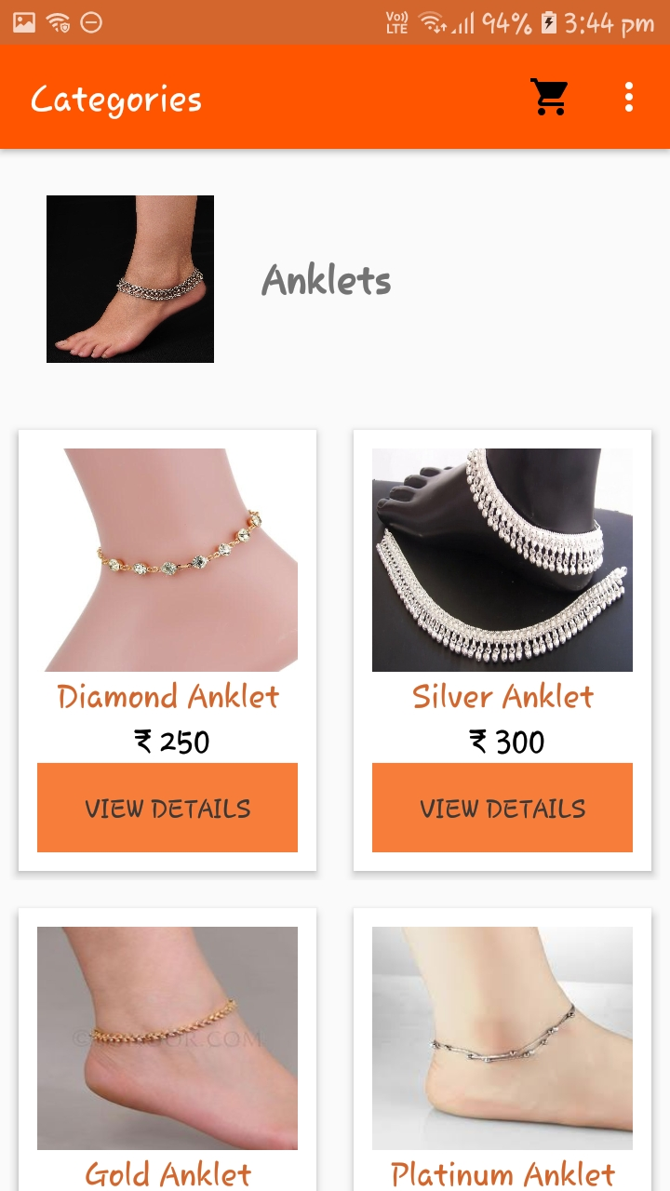

**Fig: 3.34 View Product’s Page**

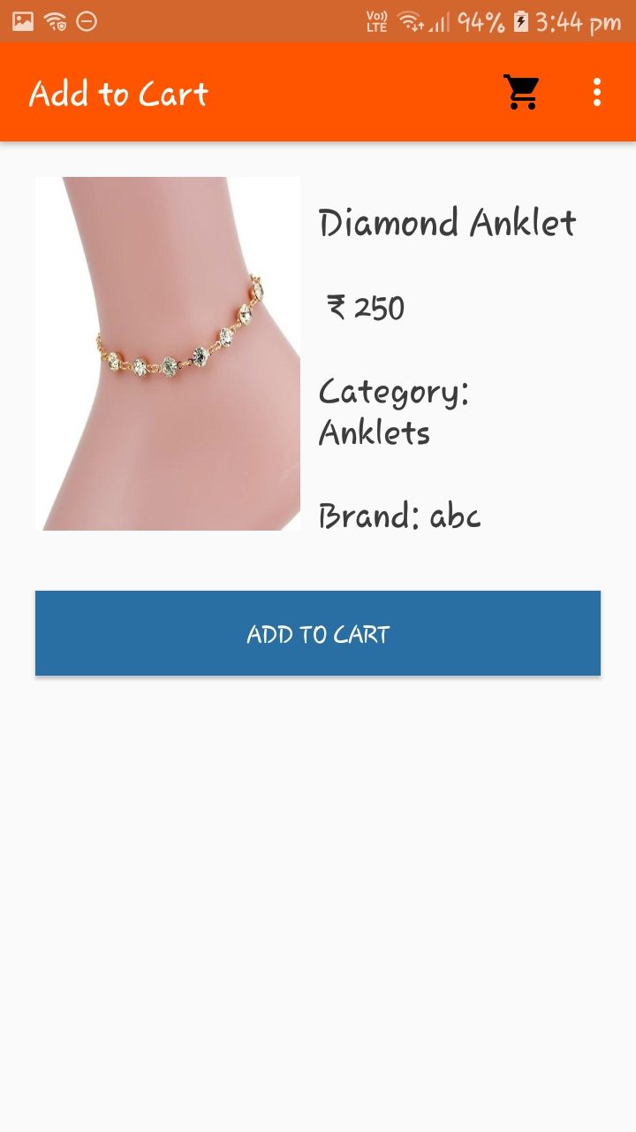

**Fig: 3.35 Product’s Detail Page**

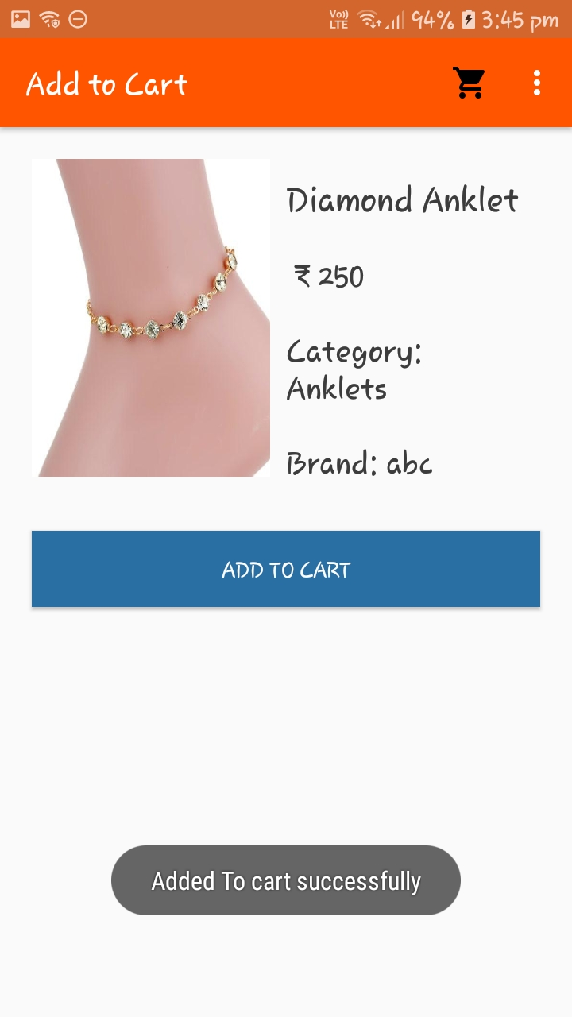

**Fig 3.36 Add to Cart Item Successfully**

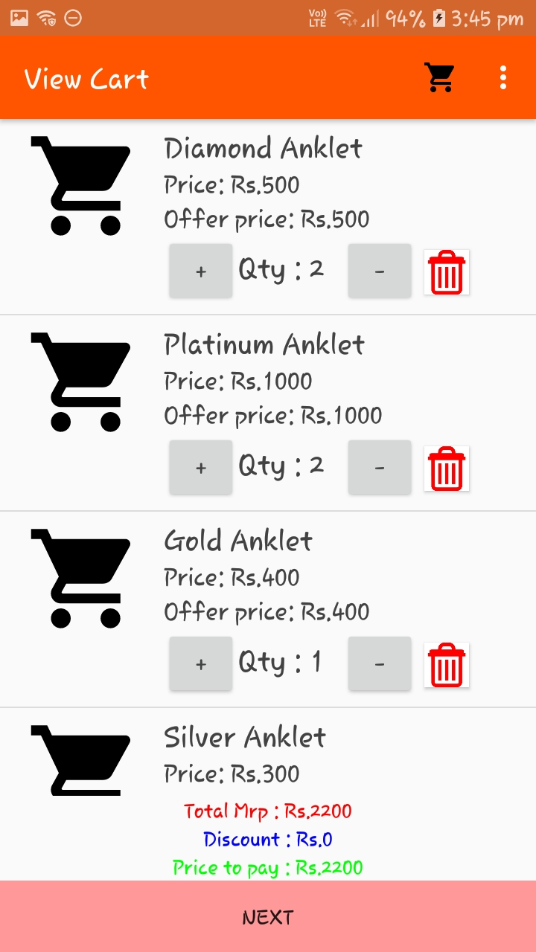

**Fig 3.37 View Cart Detail**

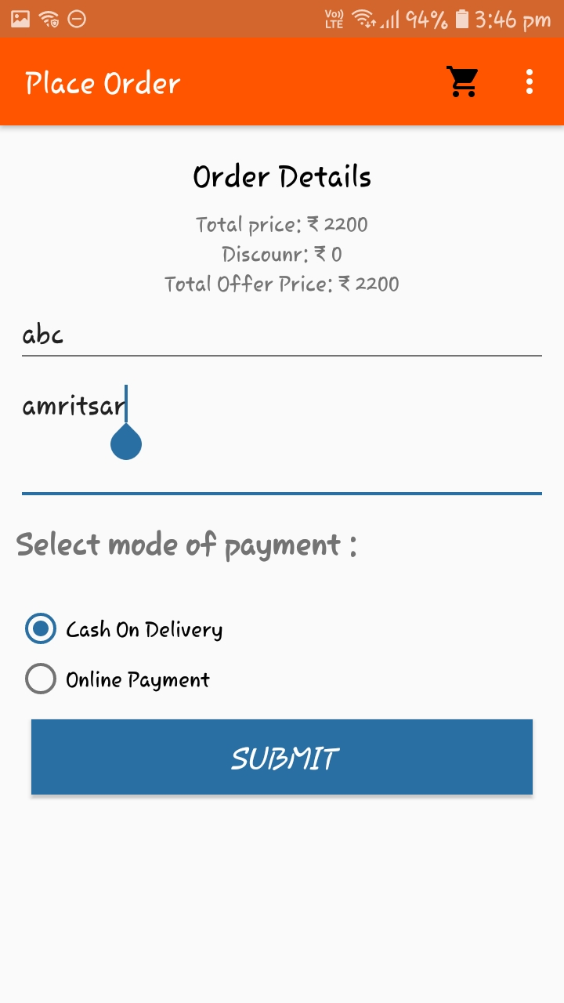

**Fig 3.38 Place Order Detail and Mode of Payment Page**

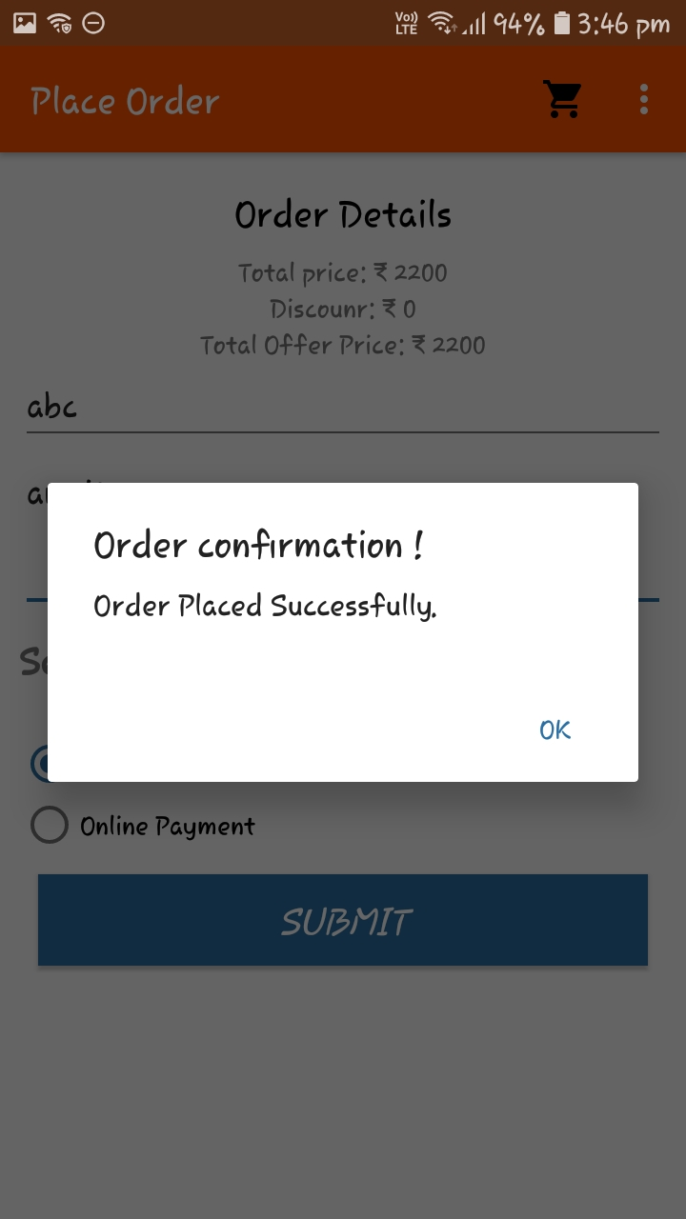

**Fig 3.39 Place order Successfully**

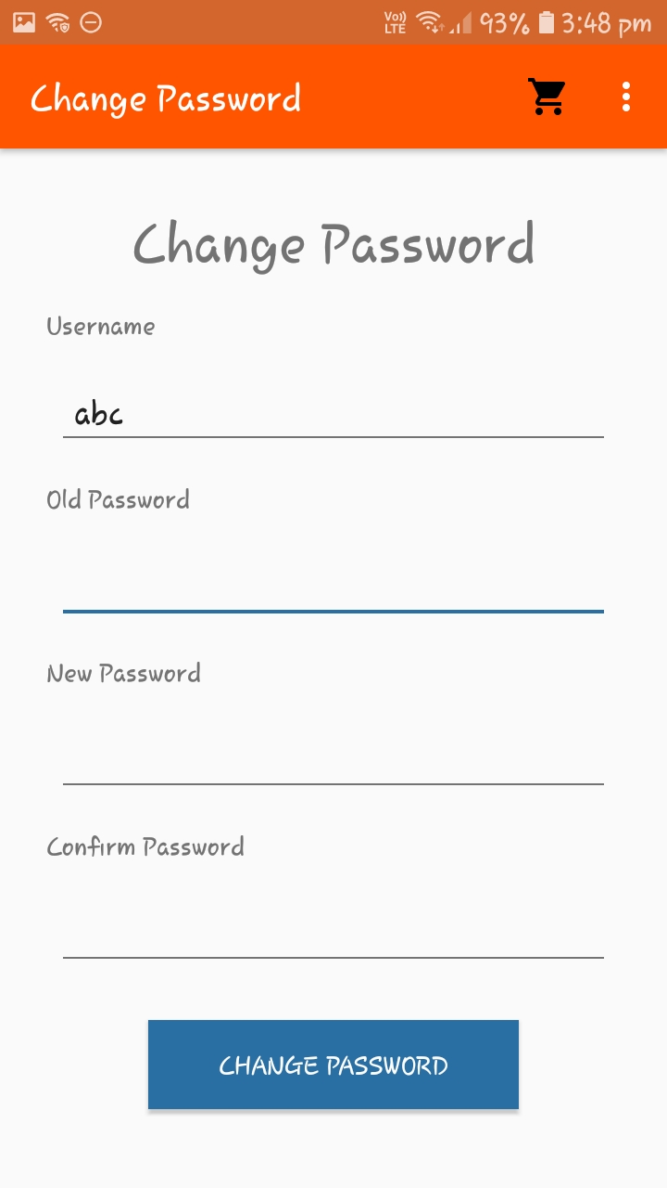

**Fig 3.40 Change Password Page**

**CHAPTER 4**

**RESULTS AND DISCUSSIONS**

**4.1) Need of Online Jewellery Shopping**

Online Jewellery Shop is basically used to build an application program which help people to find and buy latest design of Jewellery with different categories like Anklets, Bracelets, Chains etc. It is useful in the way that it makes an easier way to buy products online.

Today most of the Jewellery shop is useful for shopping site. The admin have lots of paper work and they are using desktop, spread sheet like MS Excel application to manage data in soft copy about user record. In this proposed Jewellery System it will run in server and user can handle whole the registration activities. It has facilities to generate various types of reports (like pdf, excel) which are required by the management during event organizing.

This application maintains the centralized database so that any changes done at a location reflects immediately. This is an online tool so more than one user can login into system and use the tool simultaneously.

The aim of this application is to reduce the manual effort needed to manage transactions and historical data used in various gods owns. Also this application provides an interface to users to view the details about events.

**CHAPTER-5**

**Conclusions and Future Scope**

**5.1) Future of Online Jewellery Shopping**

The scope of this system is to provide user comfortable environment of Purchasing and selling products and services over the internet without the need of going physically to the market is what online shopping all about. Online shopping is just like a retail store shopping that we do by going to the market, but it is done through the internet. Online shopping has made shopping painless and added more fun.

Online stores offer product description, pictures, comparisons, price and much more. Few examples of these are Amazon.com, ebay.com, [framt.com](http://www.framt.com/) and the benefits of online shopping is that by having direct access to consumer, the online stores can offer products that cater to the needs of consumer, cookies can be used for tracking the customer selection over the internet or what is of their interest when they visit the site again. Online shopping makes use of digital technology for managing the flow of information, products, and payment between consumer, site owners and suppliers. Online shopping can be either B2B (business to business) or B2C (business to consumer)

Shopping cart is one of the important facility provided in online shopping, this lets customer to browse different goods and services and once they select an item to purchase they can place the item in shopping cart, and continue browsing till the final selection have in the database. Limited access is available to the operator. As this is generic software it can be used by a wide variety of outlets (Retailers and Wholesalers) to automate the process of manually maintaining the records related to the subject of maintaining the stock and cash flow.

**BIBLIOGRAPHY**

To bring the system to verge of completion the following books have been referred:

|  |  |
| --- | --- |
| **NAME OF THE BOOK** | **AUTHOR’S NAME** |
| Java : The Complete Reference | Herbert Schildt |
| Beginning Android 4 Application Development | Wei-Meng Lee |

Some websites referred are:-

1. <http://developer.android.com/guide/components/fundamentals.html>
2. <https://www.w3schools.com>
3. <https://www.shutterstock.com>
4. <https://www.tutorialspoint.com>